Daniel Paul Millet Sr.
October 13, 1931 – April 24, 2010
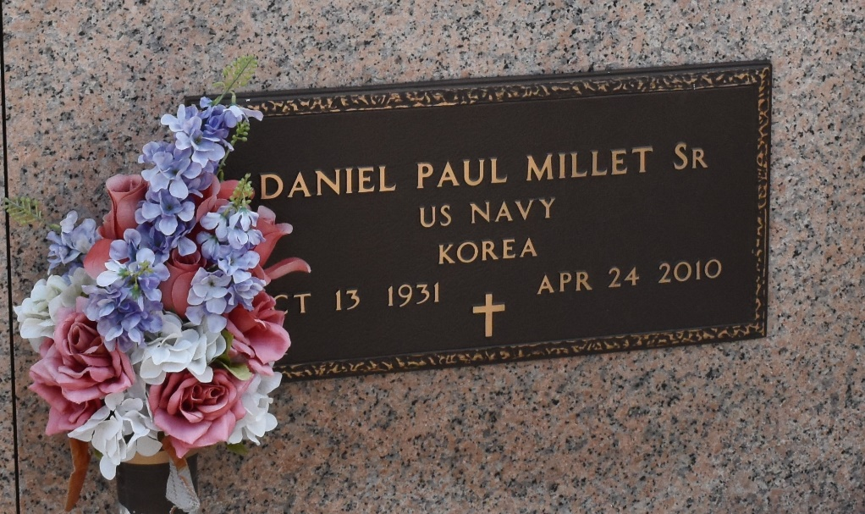

Daniel P. Millet Sr. passed away Saturday, April 24, 2010. He was the beloved father of Zina Madere and husband Blaine, and Daniel Millet Jr. and wife Tammy, and grandfather of Harmonie Marks, Blaine Madere Jr., Angel Tanner, Justin Millet and Kristie Lacarbo. Also survived by five great-grandchildren. He was the former husband of Barbara Millet. Preceded in death by a brother and three sisters. He was 78, a Navy veteran of the Korean War and a volunteer firefighter with the Rosehill Fire Department. He was a native of LaPlace and a resident of St. Amant.
Relatives and friends, also employees of Shell Chemical and Rosehill Fire Department are invited to attend services. Visitation at Millet-Guidry Funeral Home, 2806 W. Airline Highway, LaPlace, on Tuesday, April 27, from 5 p.m. until 9 p.m. and Wednesday from 8 a.m. until 9:45 a.m., followed by a Mass at St. Joan of Arc Catholic Church, LaPlace, at 10 a.m. Burial in St. John Memorial Gardens Cemetery, LaPlace.
The Advocate, Baton Rouge, Louisiana
Apr. 27, 2010

