Debra (Chauvin) Millet

Abt. 1957 – August 28, 2018

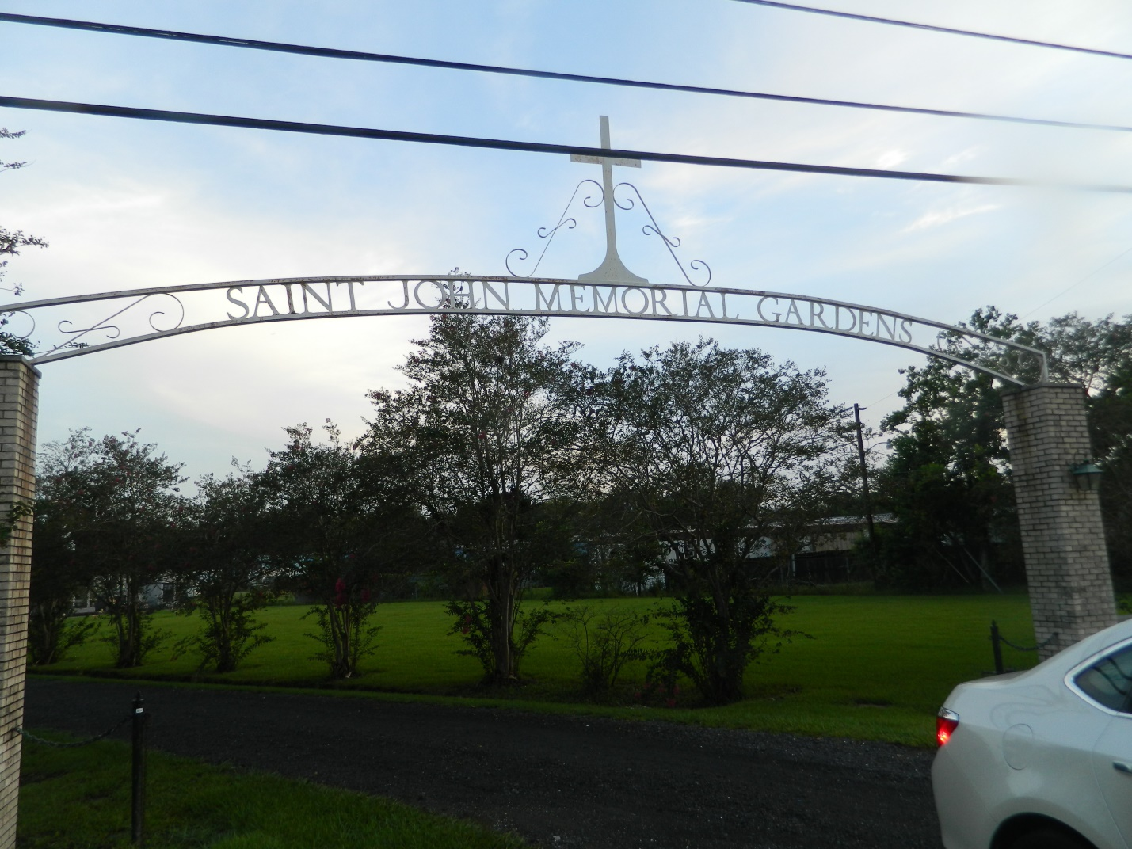

Debra Chauvin Millet passed away on Tuesday, August 28, 2018. She was 61, born in New Orleans, LA and was a resident of LaPlace, LA. Beloved wife of the late James ‘Toe’ W. Millet. Mother of Michelle Millet Cazenave (Jared). Grandmother of Henry James Cazenave and Zeke Alexander Cazenave. Daughter of the late Dorothy Schexnayder Chauvin and Joseph Chauvin.

Relatives and friends are invited to attend the Funeral Mass at St. Joan of Arc Catholic Church, 529 W 5th Street, LaPlace, LA on Saturday, September 1, 2018 at 11:30 a.m. Visitation at the church from 9:30 a.m. until 11:30 a.m. Interment in St. John Memorial Gardens Cemetery.

Millet-Guidry Funeral Home online obit (accessed 8/30/2018)