James Warren Millet
July 24, 1948 – December 4, 2004
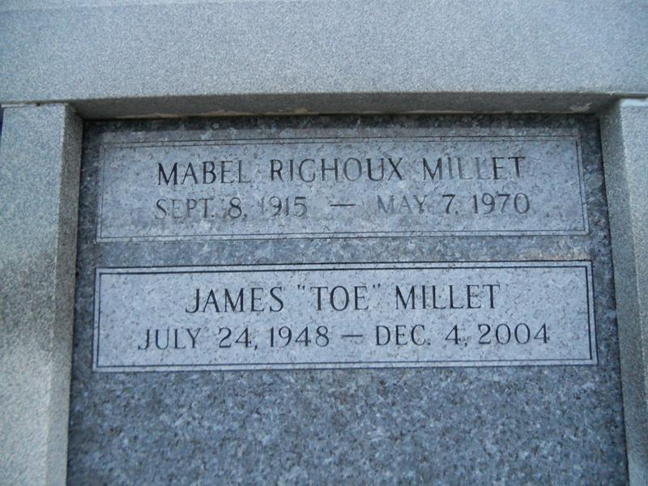
MASONIC PROGRESSIVE LODGE #262.
Officers and members are requested to attend the services of our late Brother James W. Millet on Monday, Dec. 6th at Millet-Guidry F.H., 2806 W. Airline Hwy from 5 - 9pm.
By Order of Russell Fetty, WM

Contributed by Jane Edson
**
James 'Toe' W. Millet passed away on Saturday, December 4, 2004, At 10:10 AM. Beloved Husband Of Debbie Chauvin Millet. Father Of Michelle Millet. Son Of The Late Charles 'June' And Mabel Richoux Millet. Brother And Brother-In-Law Of Betty June And Ray Vice, Gilbert 'Boe' And Carolyn Millet, Barbara P. And The Late Michael P. Millet. Also Survived By A Host Of Nieces, Nephews And Great Nieces And Nephews. Age 56 Years. A Native And Lifelong Resident Of LaPlace.
Times-Picayune, The (New Orleans, LA)
Sunday, December 5, 2004

