Joseph S. Millet
October 18, 1923 – April 18, 2006

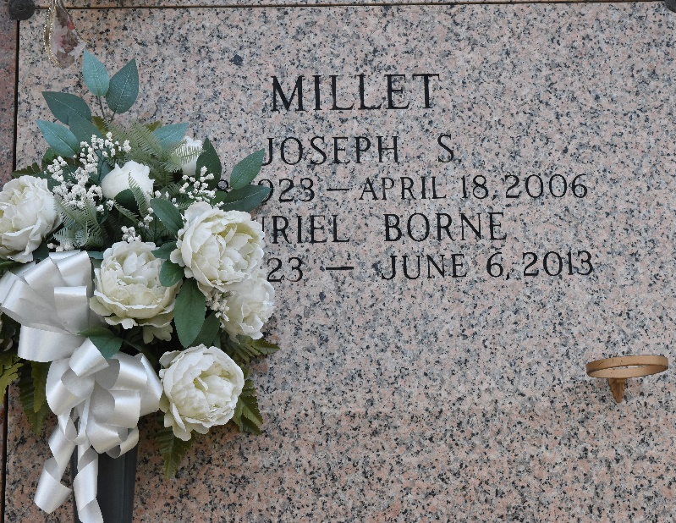

Joseph S. Millet, age 82, on Tuesday, April 18, 2006 at 6:59 p.m. in LaPlace, LA. He is survived by his beloved wife of 61 years, Muriel Borne Millet; 4 children: Glen Millet and his wife, Catherine of Gramercy, LA, Elizabeth Millet Hebert and her husband, Richard of LaPlace, LA, Margaret Millet Laiche and her husband, Edwin ""Squint'' of LaPlace, LA and Eugene ""Zip'' Millet and his wife, Belinda of Reserve, LA. He is also survived by 9 grandchildren: Kevin Millet, Casey Millet, Jessica Millet, Dixon Laiche, Aimee Fabre, Jason Fabre, Lizzette Fuselier, Megan and Monica Millet; 9 great-grandchildren: Gracie and Maddie Millet, Eathan and Aaron Millet, Ray, Wyatt and Sarah Laiche, Ori Fabre and Eli Fuselier. He is also survived by sister, Ethel Millet Weber; and nieces and nephews.
Preceded in death by his father, Levy Millet and mother, Veleda Hymel Millet; brothers: Charles ""June'' and Etienne Millet; and sister, Thelma Millet Pizzolato; grandchildren: Kurt Fabre, Baby Fabre, Nickie Millet and Ray Laiche; also nephews, Michael and James Millet; and niece, Betty June Vice.
A native of Montz, LA and a resident of LaPlace, LA. Joseph retired from South Central Bell in 1984 after 35 years of devoted service. He was the projectionist at Maurin's Theatre in LaPlace, LA for 30 years. After retiring from South Central Bell he worked for True Value Hardware. He served on the St. John the Baptist Parish Utility Board for 53 years and was very active in the St. John Parish 4-H Program. He was on the Selective Service Board of Louisiana, was one of the founding members of the Knights of Columbus and an active member of his church parish, St. Joan of Arc.
Relatives and friends of the family are invited to attend services. Visitation at MILLET-GUIDRY FUNERAL HOME, 2806 W. Airline Hwy., LaPlace, LA on Thursday, April 20, 2006 from 5 PM until 9 PM and on Friday, from 8 AM until 9:45 AM, followed by religious services at St. Joan of Arc Catholic Church, LaPlace, LA at 10:00 a.m. Burial in St. John Memorial Gardens Cemetery, LaPlace, LA.

The Times-Picayune, New Orleans, Louisiana
Apr. 20, 2006

