Constance Yvonne (Holben) Milne
September 18, 1934 – June 4, 2011

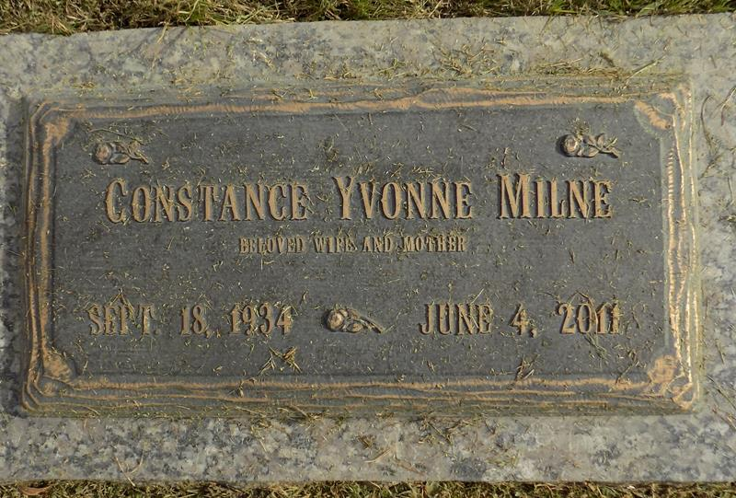

Constance Yvonne Holben Milne, 76, died peacefully with family on Saturday, June 4, 2011 in Chandler, Ariz. Passionate about dancing, traveling, gardening and her family, she made friends everywhere and with everyone. Connie was born Sept. 18, 1934, to Charles and Helen Holben in Wyandotte, Mich., living in and around Dearborn, Mich., and Pasadena, Texas. After marrying the love of her life, William George Milne, Connie lived in Michigan, Alabama, Italy and Turkey before settling for 42 years in Louisiana, first in New Orleans, then Baton Rouge and finally LaPlace, where she and Bill raised four children.
After Bill passed in 1987, Connie knew that life needed to go on. Dancing five or six days a week, especially Cajun and country, gardening noon and night, bowling and always ready to help a friend or take on a challenge, she thrived for many years. Fearless and always ready for a new adventure, the last 20 years of her life were a whirlwind of journeys and home projects. In 2005, she downsized her home to live near daughter Janet in Denton, Texas, then in 2010 moved to Gilbert, Ariz. Her struggle with cancer lasted from 2007 to 2011.
She was predeceased by her parents, by brother Richard and sister Barbara, and husband William. She is survived by two brothers, Earl and Carl, and four children, Mark Milne, Janet Rainbolt (Mark), Scott Milne (Marilyn) and James Milne as well as seven grandchildren, two great-grandchildren and 12 nieces and nephews. She leaves behind friends from coast to coast, each with memories of "Crazy Connie" that always bring smiles.
A service was held Friday, June 10, at Millet-Guidry Funeral Home in LaPlace, with burial at St. John Memorial Gardens. In lieu of flowers, please make donations to the American Cancer Society, Hospice of the Valley (Phoenix) or a charity of your choice.
L'Observateur, LaPlace, Louisiana
Saturday, June 11, 2011

