Peggy Ann (Keating) Mire
February 18, 1959 – December 4, 2006
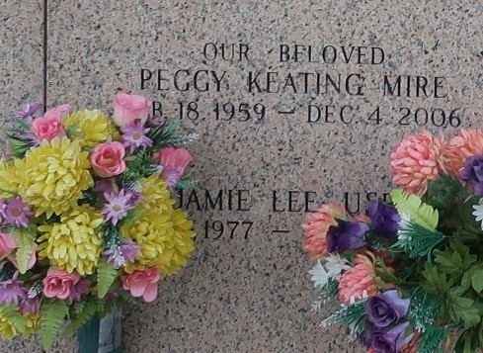

Peggy Keating Mire, on Monday, December 4, 2006 at 9:06 p.m. Beloved wife of Glenn Mire. Mother of Shawn, Elliot and Holly Mire. Daughter of Gary Keating and the late Marion Keating. Sister of Gary Keating, Jr., Susan Abt, Nancy Keating and Janet Torres. Age 47 years. A native of Laplace, LA and a resident of Reserve, LA for the past 20 years.
Relatives and friends of the family are invited to attend services. Visitation at Millet-Guidry Funeral Home, 2806 W. Airline Hwy, LaPlace, LA on Wednesday, December 6, 2006 from 5:00 pm to 8:00 pm and on Thursday from 8:00 am to 10:00 am. Followed by Religious Services at the Funeral Home Chapel at 10:00 am. Burial in St. John Memorial Gardens Cemetery, LaPlace, LA.
The Times-Picayune, New Orleans, Louisiana
Dec. 6 to Dec. 7, 2006

