Barbara Francis (Bright) Mitchell
December 21, 1943 – April 19, 2017
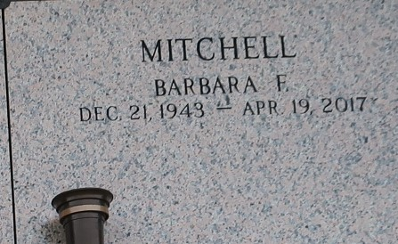

Barbara Francis Mitchell passed away peacefully on Wednesday April 19, 2017 at the age of 73. She was born December 21, 1943 to the parents of Mr. Victor Bright and Ms. Evelyn Bright. Barbara was a loving wife, mother, grandmother, sister and friend. She will be truly missed by everyone that knew her. She leaves behind in mourning her devoted husband Royal Mitchell Jr., daughter Dion Brown, three sons; Royal Mitchell III, Desmond Mitchell and Trevis Mitchell; brother Ulysses Bright Jr., five sisters; Sylvia James, Diane Johnson, Marylee Nelson, Lorie Reed, Geraldine Bright and a host of grandchildren, nieces, nephews, cousins and friends. She is preceded in death by both parents; Victor Bright and Evelyn Simmons, her son Shannon Mitchell Sr., sisters Peggy Hawkins, Willa Mae Cureaux, Betty Devare and her brother Herman Bright.
Complimentary viewing will be held from 2-4pm on Friday April 28, 2017 at the Baloney Funeral Home, LLC located at 1905 W. Airline Hwy, Laplace, Louisiana 70068. Funeral service will take place on Saturday April 29, 2017 at First Community Antioch Baptist Church located at 10860 Highway 3125, Lutcher, Louisiana 70071. Viewing beginning at 9:00am followed by funeral service for 11:00am. Pastor David B. Carter officiating. Immediately following will be the burial service held at St. John Memorial Garden located at 2205 W. Airline Highway, Laplace, Louisiana 70068. Arrangements Entrusted to the Baloney Funeral Home, LLC, 1905 W. Airline Highway, Laplace, Louisiana 70068 (985)224-8460. Condolences can be expressed at www.baloneyfuneralhome.com

Baloney Funeral Home, LaPlace, Louisiana

