Cleveland H. Mitchell Sr.

April 20, 1941 – November 3, 2003

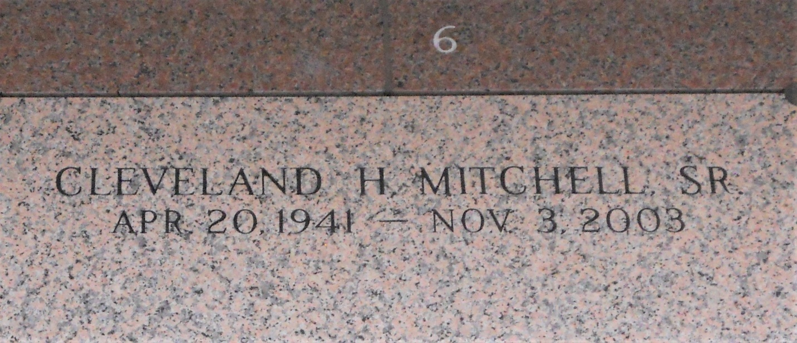

Photo by Team T Lo

Cleveland H. Mitchell, Sr. On Monday, November 3, 2003 At His Residence In Reserve, La. Husband Of Sophie Mitchell. Son Of Theresa Mitchell And The Late Herman Mitchell, Sr. Father Of Wayne, Darlene, Cleveland, Jr. And Shantrell Mitchell. Brother Of Velma M. Harris, Betty Mcclendon, Diana Stewart, Joann Bailey, Calvin, Wilbert, Herman And Whitney Mitchell. Also Survived By 7 Grandchildren And A Host Of Nieces, Nephews, Other Relatives And Friends. Age 62 Years. A Native And Resident Of Reserve, La.

Relatives And Friends Of The Family, Also Pastors, Officers And Members Of Providence Baptist Church No. 2 And All Neighboring Churches Are Invited To Attend The Funeral At Providence Baptist Church No. 2, 152 Union Lane, Montz, La, On Saturday, November 8, 2003 At 10:00 Am. Rev. Donald Brown, Sr., Pastor, Officiating. Interment St. John Memorial Gardens Cemetery, Laplace, La. Visitation At The Above Named Church From 9:00 Am Until Service Time. Serviced By Robottom

Times-Picayune, New Orleans, Louisiana

November 7, 2003