Da’Nija Da’nee Mitchell
January 5, 1998 – December 22, 2021
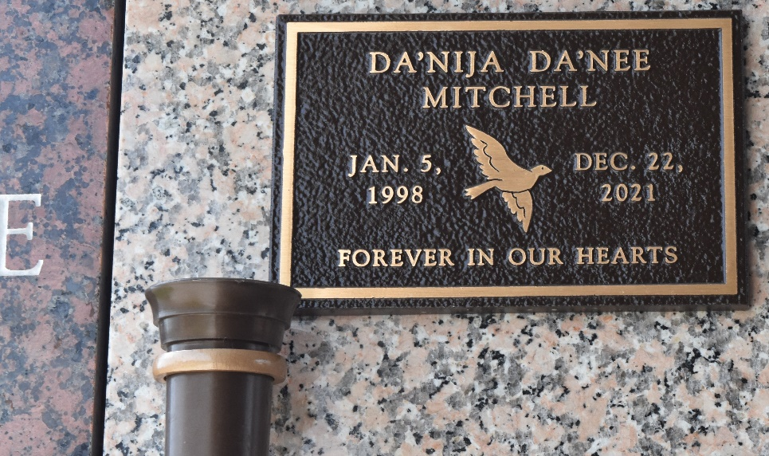

Da'Nija Danee Mitchell departed this earthly life on Thursday, December 23, 2021, age 23, daughter of Damian Mitchell and Carol Kanzig, mother of Xavier Ray II, sister of Akiera, A'Leilawh, Autemus, Jr., Autemus III, Austin, Connor, Damian Jr., Deddric, Dylan, and Josiah. Danija is also survived by her grandparents, and a host of other relatives, cousins and friends.
Funeral Service will be held on Saturday, January 8, 2022 at 1:00 pm at New Wine Fellowship, 1929 W. Airline Hwy., LaPlace, LA, Visitation at 12:00 noon, Rev. Willie Smith officiating. Due to CDC (COVID-19) restrictions, seating may be limited. Masks and social distancing are required. Professional services entrusted to the caring staff of Hobson Brown Funeral Home, 134 Daisy St., Garyville, La. 70051, 985-535-2516.

The Times-Picayune, New Orleans, Louisiana
Jan. 6 to Jan. 8, 2022

