Eunice Mitchell
April 6, 1941 – November 22, 2016
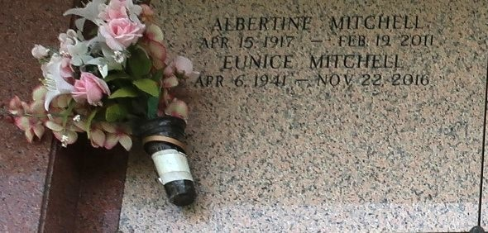

Eunice Mitchell, departed this life on Tuesday, November 22, 2016, at the age of seventy-five. The third of eight children, born in New Orleans, La. April 6, 1941 she is preceded in death by her parents; Royal Sr. and Albertine Francis Mitchell; two brothers; Warren and Norris Mitchell; two sisters; Dorothy and Iris Mitchell. Memories of her will forever be etched in the hearts and minds of her brother, Royal Mitchell, Jr.; two sisters, Joyce M. Jackson and Carolyn M. McKnight; two brothers-in-law, Andrew Jackson, Willie McKnight; two sisters-in-law, Barbara and Odile Mitchell, two godchildren, Roycheca Johnson, and Darrell Coleman. Devoted friends Betty Grover & Loretta Young, and host of NEPHEWS, NIECES, COUSINS AND FRIENDS.
Visitation to be held at The Baloney Funeral Home located at 1905 West Airline Highway, LaPlace, LA. 70068 on Friday, December 2nd, 2016 from 2:00PM-5:00PM. Funeral Services will be held at Greater New Plymouth Baptist Church located at 110 NW 13th Street, Reserve, LA. 70084 on Saturday, December 3rd, 2016 at 11:00 AM. Viewing will be from 9AM-until time of service. Officiating, Reverend David B. Carter. Interment will be at Saint John Memorial Gardens Cemetery, located at 2205 W Airline Hwy., LaPlace, LA. The Repass will be held at the church immediately following the service. Funeral arrangements entrusted to The Baloney Funeral Home located at 1905 West Airline Highway, LaPlace, LA. 70068 (985) 224-8460. Condolences may be offered at www.baloneyfuneralhome.com.

Baloney Funeral Home, LaPlace, Louisiana

