Geraldine Partee Mitchell
April 18, 1962 – September 14, 2021
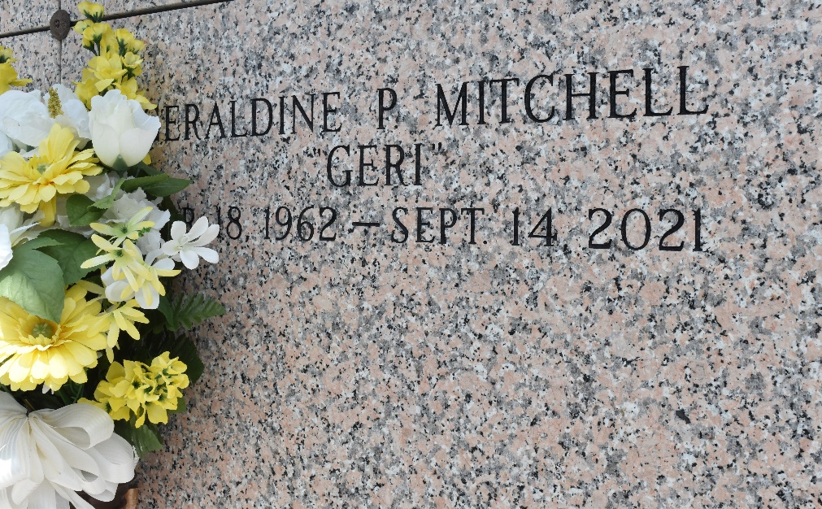

Geraldine Partee Mitchell, departed this earthly life on Tuesday, September 14, 2021. Daughter of the late Joseph Moore and Ida Magee., Mother of Kenneth Jr., Latoya, Kendrick Sr. (Kayla), Jasmine, Akeem (Brandy) Mitchell, and Nairobi Dennis. Geraldine is survived by her grandchildren, brother and sisters, and a host of other relatives, cousins and friends.
Funeral Service will be held on Monday, September 27, 2021 at Beech Grove B.C., 117 Beech Grove Dr., Reserve, LA 70084, Pastor Corey Batiste, Officiating, Visitation from 8:00am until service time. Interment at St. John Memorial Laplace, La 70068. Due to CDC (Covid19) restrictions seating may be limited, mask and social distancing are required. Professional Services entrusted to the Caring Staff of Hobson Brown Funeral Home, 134 Daisy St., Garyville, La 70051, (985) 535-2516.
The Times-Picayune, New Orleans, Louisiana
Sep. 26 to Sep. 27, 2021

