Mark D. Mitchell
July 9, 1971 – April 23, 2020
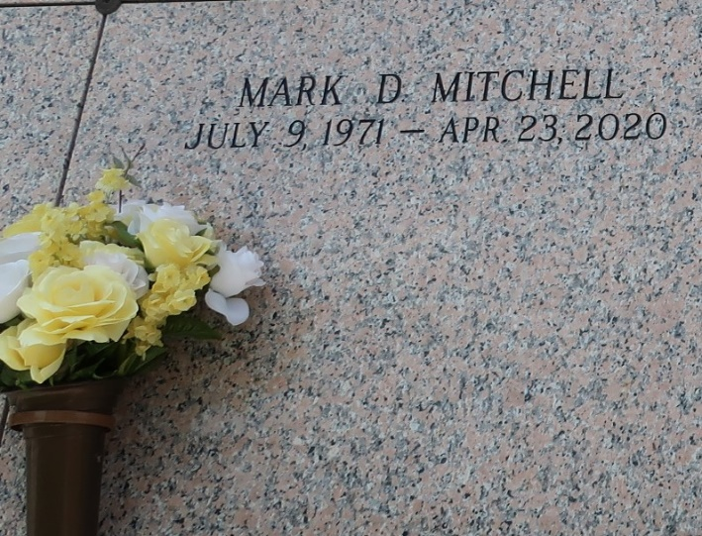

Mark D. Mitchell passed away on Thursday, April 23, 2020 at his home in LaPlace, LA. He was the son of Carrie M. and Hilton Mitchell, Jr., father of Shamar Diggs, brother of Stephanie Coleman and Thaddeus Mitchell (Barbara). He was also survived by 1 niece, 3 nephews, cousins, other relatives and friends. He was 48 years old, a native of Reserve, and a resident of LaPlace. Fr. Christopher Armadi, Celebrant. Due to restrictions of the COVID 19 pandemic, a private graveside service was held at St. John Memorial Garden Cemetery, Laplace, LA. Serviced by Robottom.
The Times-Picayune, New Orleans, Louisiana
Apr. 30 to May 1, 2020
Contributed by Jane Edson

