Norris Mitchell

October 18, 1942 – March 30, 2012

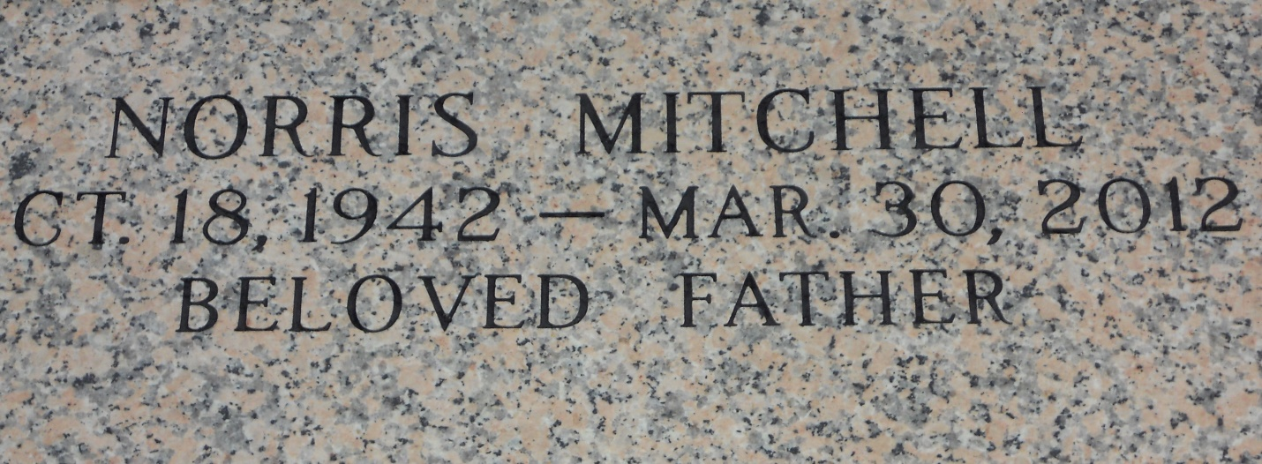

Photo by Team T Lo

Norris Mitchell, age 69 yrs., departed this earthly life and entered into eternal rest on Friday, March 30, 2012 at St. Charles Hospital of Luling, LA. Beloved father of Monica (Darryl) Patterson and William Warren, Jr. of Los Angeles, CA. and Melodi (Marcus) Carter of Suffolk, VA. Brother of Royal (Barbara) Mitchell, Jr. of Reserve, LA, Joyce Jackson of Los Angeles, CA, Carolyn (Willie) McKnight and Eunice Mitchell of Kenner, LA and the late Warren Mitchell. Sister-in-law of Odile Mitchell of Garyville, LA. Also survived by 5 grandchildren, nieces, nephews, other relatives and friends.  
  
Relatives and friends of the family, also pastors, officers and members of the Israelite Baptist Church of Lutcher, LA and all neighboring churches are invited to attend the funeral services on Saturday, April 7, 2012 at 11:00 AM at the Israelite Baptist Church, 2192 Alexander St., Lutcher. Rev. Kevin Frederick officiating. Visitation will be at the above named church from 9:00 AM until service time. Interment in St. John Memorial Garden of Laplace, LA.  
  
Bardell's Mortuary of Mt. Airy, LA in charge. Information: 985-835-6837

Times-Picayune, The (New Orleans, LA) - Friday, April 6, 2012

Contributed by Jane Edson