ShaAndra L. Mitchell
January 1, 1993 – December 16, 2020
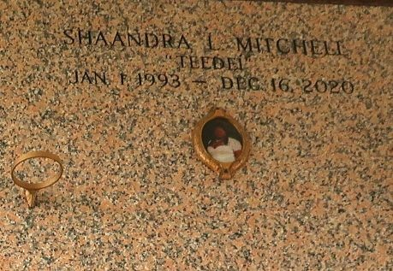

ShaAndra L. Mitchell died unexpectedly on Monday December 16, 2020 in New Orleans, Louisiana at the age of 27. ShaAndra is survived by her Parent Ruby Patterson Mitchell, her siblings Lakeisha Mitchell, Tyrone (Sharika) Mitchell, nieces, nephew other relatives and friends. ShaAndra is preceded in death by her father Tyrone Mitchell Sr.
Funeral service on Friday January 1, 2020 at LaBelle Place Reception Hall 1905 W. Airline Hwy Laplace, La at 11:00am. Visitation from 10am until service time. (Only) Minister Denarold Anderson, Officiating. Interment St. John Memorial Laplace, La. Due to CDC (Covid19) restrictions seating is limited, mask and social distancing are required. Professional Services entrusted to the Caring Staff of Hobson Brown Funeral Home, 134 Daisy St., Garyville, La 70051, (985) 535-2516.

The Times-Picayune, New Orleans, Louisiana
Dec. 30, 2020 to Jan. 1, 2021

