Tyrone L. Mitchell

Abt. 1959 – November 21, 2018

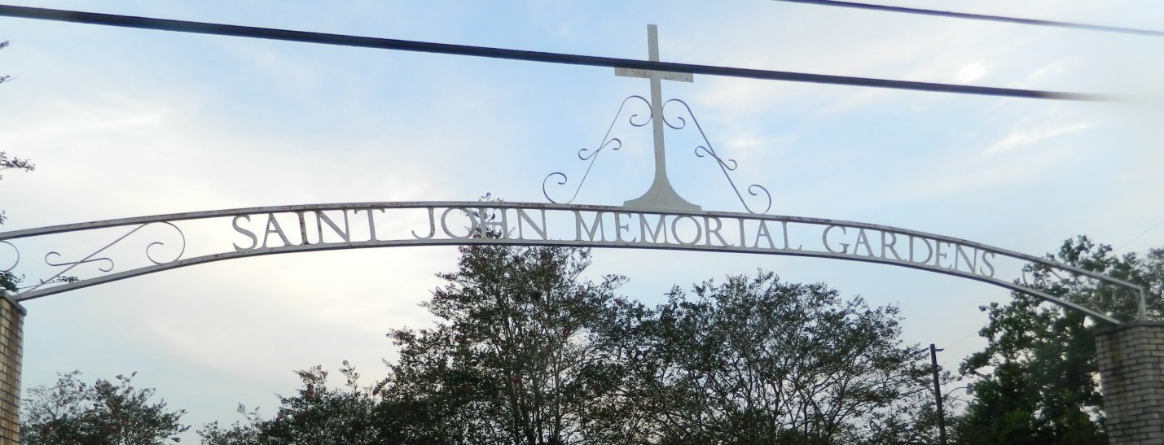

Tyrone L. Mitchell pass away on Wednesday, November 21, 2018 at the age of 59., Tyrone leaves to cherish his memories his wife Ruby Patterson Mitchell, children ShaAndra Mitchell, Lakeisha (Delano) Burton, and Tyrone (Sharika) Mitchell, grandchildren Malika' Jones, A'lia Burton and Na'tae Mitchell, 2 brothers and six sisters, 1 uncle, a host of other relatives and friends.

Relatives and friends are invited to attend the homegoing celebration on Saturday December 8, 2018 at 11:00 a.m. at Beech Grove B.C., 117 Beech Grove Dr., Reserve, La 70084. Visitation at 10 am until service time. Rev. Corey Batiste officiating. Interment in St. John Memorial Cemetery, Laplace, LA. Professional services entrusted to the caring staff of Hobson Brown Funeral Home, 134 Daisy St. Garyville, La 70051. 985-535-2516

Published in [TheNewOrleansAdvocate.com](http://theneworleansadvocate.com/) from Dec. 6 to Dec. 8, 2018

Contributed by Jane Edson