Wanda Marie Mitchell
December 7, 1957 – March 27, 2020

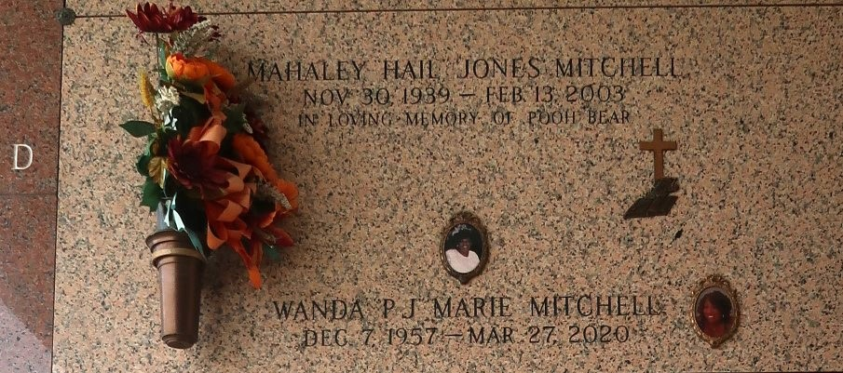

The glamorous Wanda, affectionately known as "PJ", with the infectious laugh and beautiful smile departed this world on March 27, 2020 at the age of 62. On December 7, 1957 Wanda Marie Mitchell was born to the union of Mahaley Jones Mitchell and Isiah Mitchell. Wanda was the second oldest among 10 children. Wanda was a Graduate of Leon Godchaux High School, and the University of New Orleans where she completed her studies in Business and Finance.
Wanda worked most of her years in the hotel industry as a night auditor. Wanda will be truly missed by her only child Ycovia Gabrielle Mitchell, 5 sisters, Lori Mitchell Dennis, Yolanda Mitchell Searcy, Stacey Johnson, Bridget Mitchell Bartley, and Delvikia Mitchell Joseph, 2 Brothers, Kenneth Mitchell Sr. and Patrick Mitchell. 4 brother in laws, Joseph Dennis, Rickey Searcy Sr., Warren Joseph Sr., Dalton Johnson 3rd, 3 sister- in- laws, Ruby Patterson Mitchell, Janel Hutchinson Mitchell, Brenda Mitchell and a host of nieces and nephews.
The following cleared the path and parted the way to heaven for Wanda. Her mother Mahaley Jones Mitchell, father Isiah Mitchell, sister Cheryl M. Gibson and brother Tyrone L Mitchell Sr. We rejoice in the fact that Wanda is once again with her best friend and brother Tyrone L. Mitchell, Sr. We can only imagine the conversations they are having in heaven shouting and praising God.

Treasures of Life Funeral Services, Gramercy, LA

