Wayne Mitchell

July 16, 1966 – June 21, 2004

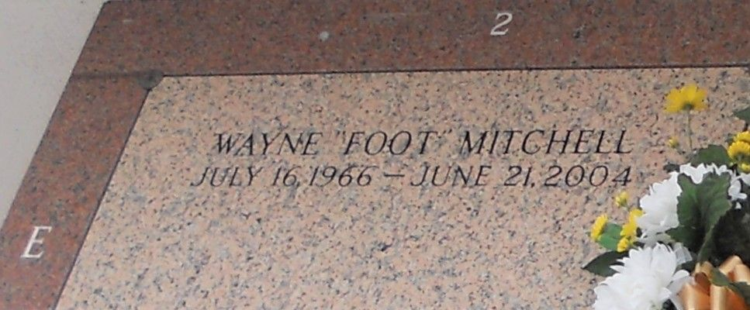

Photo by Team T Lo

Wayne Mitchell On Monday, June 21, 2004. Son Of Sophie Mitchell And The Cleveland H. Mitchell, Sr. Father Of Kenwan Moore. Brother Of Darlene, Cleveland, Jr. And Shantrell Mitchell. Also Survived By A Host Of Nieces, Nephews, Other Relatives And Friends. Age 37 Years. A Native And Resident Of Reserve, La.

Relatives And Friends Of The Family, Also Pastors, Officers And Neighbors Of Providence Baptist Church Number 2 And All Neighboring Churches Are Invited To Attend The Funeral At Providence Baptist Church Number 2, 152 Union Lane, Montz, La., On Saturday, June 26, 2004 At 10:00 Am. Rev. Donald Brown, Pastor, Officiating. Interment St. John Memorial Gardens Cemetery, Laplace, La. Visitation At The Above Named Church From 9:00 Am Until Service Time. Serviced By Robottom

Times Picayune, New Orleans, LA; June 25, 2004