James W. Moates
September 17, 1923 – September 14, 2004

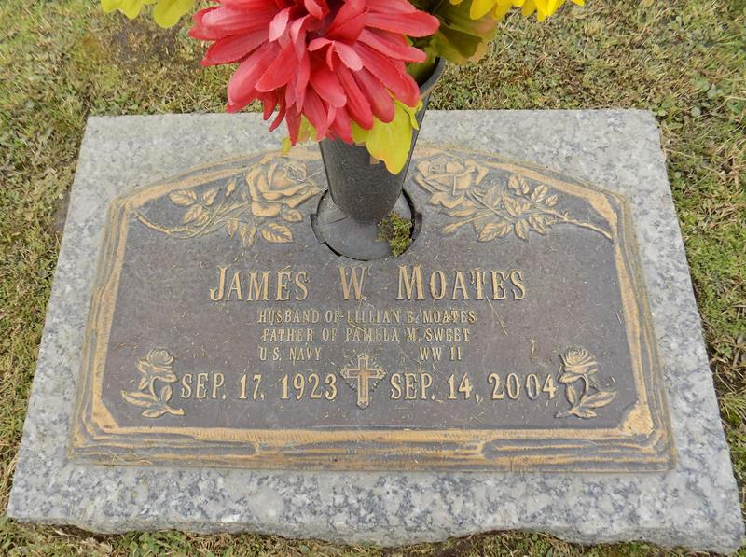

James W. Moates, on Tuesday, September 14, 2004 at 10:15 P.M. Beloved husband of the late Lillian E. Moates. Father of Pamela Moates Sweet and Father-in-law of Paul H. Sweet. He was a Navy Veteran, Shriner, Lifetime Mason Member, American Kennel Club Member and a Member of Steel Workers Union Local 5702. Age 80 years. A native of South Carolina and a resident of LaPlace, LA for the past 49 years.
Relatives and friends of the family are invited to attend services. Visitation at MILLET-GUIDRY FUNERAL HOME, 2806 W. Airline Hwy., LaPlace on Tuesday, September 21, 2004 from 5:00 P.M. until 9:00 P.M. and on Wednesday from 11:00 A.M. until 12:00 noon. Followed by Religious Services in the Funeral Home Chapel at 12:00 noon. Burial in St. John Memorial Gardens, LaPlace.
Times-Picayune, The (New Orleans, LA)
Monday, September 20, 2004

