Hilda Mae (Fobb) Molton
February 13, 1936 – January 3, 2023
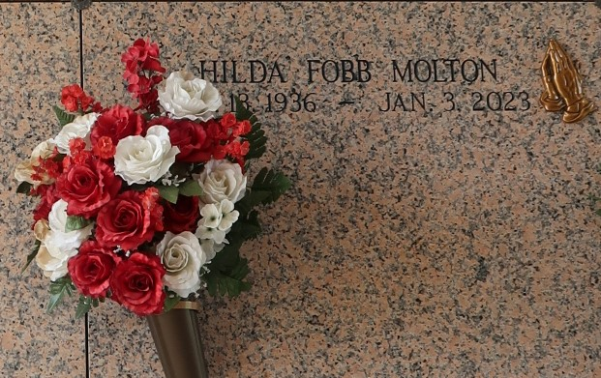

Hilda Mae Fobb Molton entered eternal rest at her home surrounded by her loving family on Tuesday, January 3, 2023 at the age of 86. Hilda was a native Laplace, LA and resident of Reserve, LA. She was the daughter of the late Shelton and Nitsie B. Fobb. The wife of the late James Molton, Jr. She was the loving mother of Melissa Ann Molton, Timothy James Molton, Sr., Dorothy Stokes and the late Saundra Molton George. She was the sister of Shirley (Hilton) Millet, Roy Fobb and the late Herfert, Herbert, Howard, William, and Peter Fobb, Corita Powers, Hazel Wilkens, Gertrude Hamilton, Daisy Joseph, Bessie Mercier, Frances Stokes, Lucille Joseph and Peggy Fobb. The daughter-in-law of the late James, Sr. and Martha Molton.
She leaves to cherish her memories her children Melissa Molton, Timothy (Melissa L.) Molton, Sr., and Dorothy Stokes. Her grandchildren Taj (Nikki) George, Jason (Jenna) George, Thomas George, Jr., Tamisha (Bennie, III) Reynolds, Keiondra (Andrew) Simpson, Dorion Stewart, Timothy Molton, Jr., Tristian McKinney, and Jasma (Danielle) Young and thirteen great grandchildren and a host of nieces, nephews, other relatives and friends.
Hilda was preceded in death by her husband James Molton, Jr., parents Shelton and Nitsie Fobb and daughter Saundra Molton George, and Granddaughter Taija Stokes.
Relatives and friends of the family, Pastors, Officers and Members of Rising Star Baptist Church of Laplace, LA., all neighboring churches, SPS3PL Services, and Lab Corp are invited to the Funeral Service at 11:00am on Friday, January 13, 2023 at Rising Star Baptist Church, 620 Cardinal Street, Laplace, LA. 70068. In accordance with the CDC guidelines for COVID-19 masks are suggested for all in attendance. Visitation 9:00am until time of service at the above-named church. Interment St. John Memorial Gardens, 2205 W. Airline Hwy, Laplace, LA. 70068. Final Arrangements Entrusted to The Patrick H. Sanders Funeral Home & Funeral Directors, Inc., 605 Main Street, LaPlace, LA 70068. For information 985-359-1919.
The Patrick H. Sanders Funeral Home, LaPlace, Louisiana

