Margie Elizabeth (Johnson) Moneyhun
September 4, 1924 – April 22, 2013
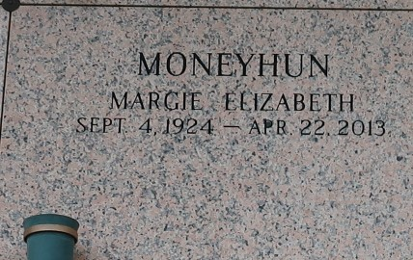

Margie Johnson Moneyhun passed away on Monday, April 22, 2013. Beloved wife of the late C.V. Moneyhun. Mother of Linda Cortez, Harold Moneyhun and Nancy Liedtky. Grandmother of Stacey, Cathy, Susan, Geordi, Brianna, Kelly and Danyel. Also survived by 11 great-grandchildren and 1 great-great-grandchild. Sister of the late Robert, Don, Ed and Gene Johnson and Marie Hood. Age 88. A native of Virginia and a resident of LaPlace.
Relatives and friends are invited to attend services. Visitation at The First United Methodist Church, 301 Bamboo Rd, LaPlace, LA on Friday April 26, 2013 from 8:00am to 10:00am, followed by Religious Services at 10:00am. Burial in St. John Memorial Gardens Cemetery, LaPlace, LA. Arrangements by Millet-Guidry Funeral Home, LaPlace, LA.
The Times-Picayune, New Orleans, Louisiana
Apr. 23 to Apr. 24, 2013

