Dennis James Montegut
February 26, 1957 – August 20, 2015
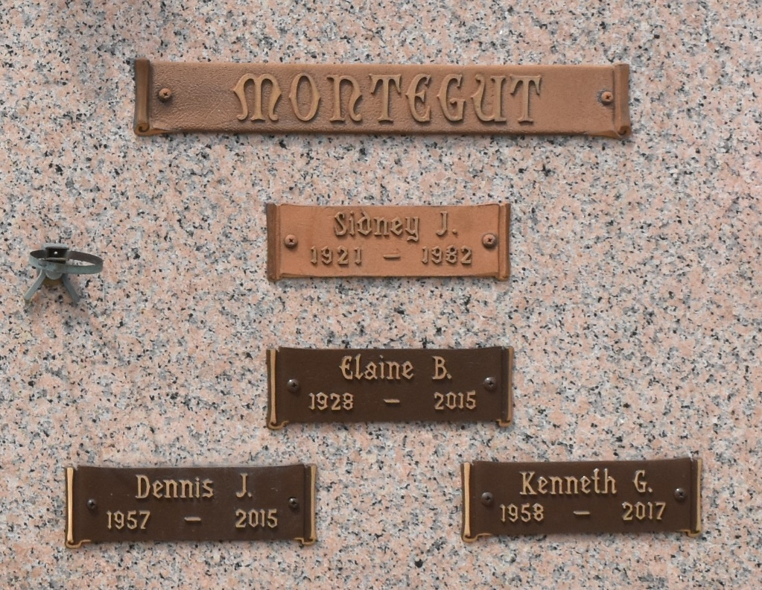

Dennis Montegut passed away on Thursday, August 20, 2015. He was 58, a native of New Orleans and a resident of LaPlace. Beloved son of the late Elaine Brown Montegut and Sidney J. Montegut. Brother of Kenneth Montegut, Thomas Montegut, Ann Montegut Felkner and Kay Montegut Garrity. Also survived by 3 nieces, 5 nephews and 1 great niece.
Relatives and friends are invited to attend the Graveside Service on Monday, August 31, 2015 at 2:00 p.m. in St. John Memorial Gardens Cemetery.

Millet-Guidry Funeral Home, LaPlace, Louisiana

