Kenneth Gerard Montegut
November 16, 1958 – January 16, 2017
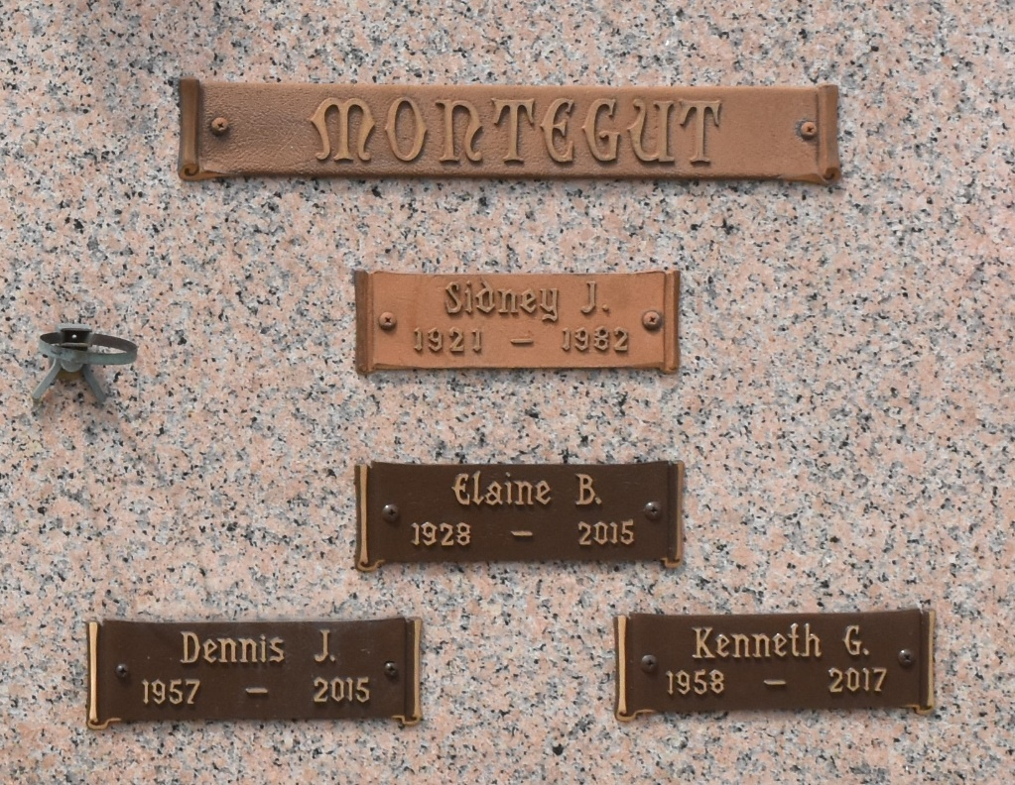

Kenneth Gerard “Hammer” Montegut, 58, of LaPlace, Louisiana passed away on January 16, 2017. Kenneth is predeceased by his parents Sidney J. and Elaine Brown Montegut as well as his brother Dennis J. Montegut. Kenneth is survived by two children, Christopher Montegut and Catherine Brehart; his brother Thomas; sisters Ann and Kay; nieces, nephews and many loving relatives and friends.
Kenneth was born in New Orleans, Louisiana on November 16, 1958. He graduated from Riverside Academy and attended Southeastern Louisiana University. Kenneth had a strong interest in local history and enjoyed reading on the topic. He also enjoyed outdoor activities, especially hunting and fishing, and was happiest engaged in these activities. He was a very sensitive man with a big heart that felt life deeply-both the good and the bad. May he rest in peace free from the adversities and struggles he faced in this physical world.
Services will be on Saturday, January 28, 2017 at Millet-Guidry Funeral Home, 2806 W. Airline Hwy in LaPlace. Visitation will be held from 1:00 p.m. - 3:00 p.m. followed by a prayer service at 3:00 p.m., and interment in St. John Memorial Gardens Cemetery.

Millet-Guidry Funeral Home, LaPlace, Louisiana

