Armand Michel Montz Jr.
June 25, 1917 – September 19, 2001
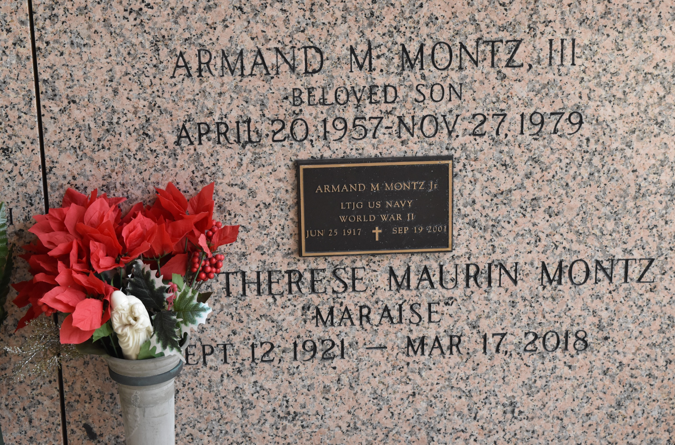

LAPLACE – Armand Michel Montz Jr., 84, a native and resident of LaPlace, died Sept. 19. He was the husband of Marie-Therese Maurin Montz and father of Sharon Brady, Gretchen Schexnayder and Jeffrey, Gerard and the late Armand Montz III. He was the son of the late Armand and Aline Perilloux Montz and brother of Nemours Montz and the late Alice Maurin. He is survived by 12 grandchildren and one great-grandchild.
He was a U.S. Navy veteran of World War II, worked in his father’s business, A. Montz & Co., and Reserve Telephone Company. He received the Order of St. Louis Medallion in 1988.
Services were Sept. 21 at St. Joan of Arc Catholic Church, LaPlace, with interment at St. John Memorial Gardens, LaPlace.
L’Observateur, Laplace, Louisiana
Sunday September 23, 2001

