Janice Lynn Moritz
February 7, 1961 – October 15, 2012

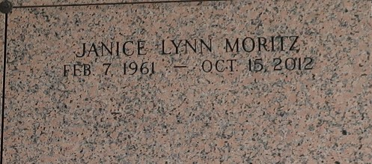

Janice Moritz passed away on Monday October 15, 2012. Beloved mother of Katie Cooke and Daniel Moritz. Daughter of Toby Moritz and the late Raymond Moritz. Sister of Richard (Janice) and David (Susan) Moritz. Age 51. A native of LaPlace, LA and a resident of Gillsburg, MS.

Relatives and friends are invited to attend services. Visitation at Millet-Guidry Funeral Home, 2806 W. Airline Hwy. LaPlace, LA on Friday October 19, 2012 from 9:00 am to 11:00 am, followed by Religious Services in the Funeral Home Chapel at 11:00 am. Burial in St. John Memorial Gardens, LaPlace, LA.

The Times-Picayune, New Orleans, Louisiana
Oct. 17 – oct 19, 2012

