Curtis Ray Morrison
1954 – May 8, 2017
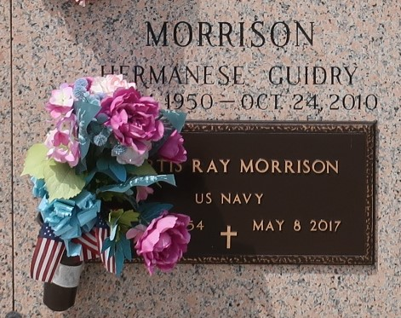

Curtis Ray Morrison at the age of 62 years departed this earthly life and entered into eternal rest on Monday May 8, 2017 at his residence in LaPlace, La. Curtis was a man truly after God's Heart, a faithful servant of God who would help anyone in need. He was a devoted member of Beechgrove Baptist Church who served on the church's Board of Directors and Pastoral Support Committee.
He was a graduate of Scotlandville High School and served in the United States Navy. Curtis worked at Cargill Inc. for 25 years and was a proud member of The Tangi Cajun Pigeon Club. He was the
Beloved son of Helen Morrison and the Late Sidney Morrison of Baton Rouge, La. Loving husband of Wilhemina Morrison of LaPlace, La. Father of Curtis Collins (Charlotte) and Troy Morrison of LaPlace, La. Stepfather of Rachel Craig (Edwin), Lattimore Brumfield, Milton Brumfield (Kenetha) and Marlon Brumfield. Brother of Brenda Williams (Darian) of Zachary, La., Alton Morrison (Iona) of Evan, Ga., Carl Morrison (Lesley) of Houston, Tx., Dewayne Morrison of Baton Rouge, La. and Kevin Morrison of Baker, La. Nephew of Gloria Collier (Joe) of Baton Rouge, La. Also survived by six grandchildren, twelve step-grandchildren, nieces, nephews other relatives and friends.
Pastor, Officers and Members of Beechgrove Baptist Church of Reserve, La and all neighboring churches are invited to attend the home going celebration on Saturday May 13,2017 at 11:00am at Beechgrove Baptist Church, 117 Beechgrove Dr. of Reserve, La. Pastor Jeff Patterson officiating. Interment in St. John Memorial Garden Cemetery of LaPlace, La. Visitation will be at the above name church from 9:00am until service time. Bardell's Mortuary of Mt. Airy, La. in charge. Information: 985-535-6837.

The Advocate, Baton Rouge, Louisiana
May 11 to May 13, 2017

