Hermanese (Guidry) Morrison
December 24, 1950 – October 24, 2010
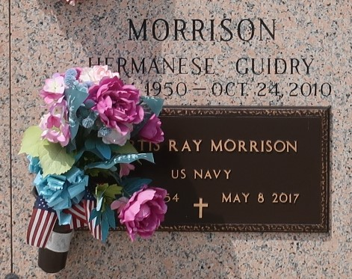

Hermanese Guidry Morrison, a loving wife, mother, and grandmother, passed away Sunday, October 24, 2010, 2:40AM at West Jefferson Hospital at the age of 59. She was a native and resident of St. John the Baptist Parish.
She leaves to cherish her memories: Curtis R. Morrison (husband), Troy C. Morrison (son), one sister-in-law, mother-in-law, five brothers-in-law, seven nieces, eight nephews and a host of relatives and friends.
Hermanese was preceded in death by her parents Willie and Margaret Guidry, sister Mercedes G. Eugene.
Visitation will be held Saturday, October 30, 2010 at Beech Grove Baptist Church in Reserve, LA from 10:00 AM until service. Service is at 11:00 AM until; Pastor Wesley Anderson Sr. Officiating. Arrangement by The Baloney Funeral Home, LLC. 985-535-2540. Guest may sign the register book at www.baloneyfuneralhome.com.

The Times-Picayune, New Orleans, Louisiana
October 29, 2010

