Curtis J. Moss Sr.
March 28, 1950 – December 25, 2020
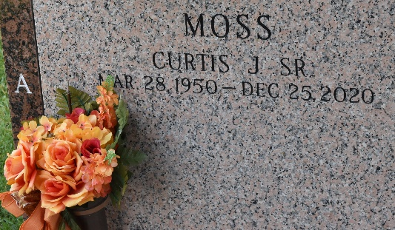
Curtis J. Moss, Sr. entered into eternal rest on Friday, December 25, 2020 at his home surrounded by his wife and family. Curtis was born on March 28, 1950. He was a native of New Orleans, LA. and a resident of Garyville for the past six years. He was educated in the New Orleans Catholic and Public-School Systems, attending St. Catherine's and later graduating from Joseph S. Clark, class of 1968. He attended Northeast Louisiana State University in Monroe, LA. He was also a United States Navy Veteran.
In the 1980's, Curtis was trained and employed as a computer engineer for Digital Equipment Corporation in San Antonio, TX. A former employee of New Orleans Sewerage and Water Board of ten years, Constar, Inc. of six years before relocating to Alexandria, LA at the Plastipak Plant as an operator/instructor for twelve years.
Curtis, a born and raised Catholic, changed his religious denomination and was baptized in 1990 at the New Wine Christian Fellowship Church by Pastor Neal Bernard of Laplace, LA. Curtis enjoyed the little things in life, such as conversing with his family, telling long, long stories about his life experiences, politics and what Thus said the Lord.
He leaves a legacy of cherished memories to his wife, Cheryl N. Moss, his children Tonya (Carl, Sr.) Thomas, Curtis Moss, Jr, Nikki (Micah) Moss Thomas, , step-sons, Ronald Jr.(Lana), Quentin (Monica) and Myron Sr.(Dayna) Nicholas, brothers, Burnie Moss, Jr. and Kenneth (Elizabeth) Moss, sisters, Joan(Lawrence) Holmes and Eldrema Moss, brothers-in-laws, Harold Sr. (Gloria) Williams, Leroy Jr. (Terry)Williams and Clarence Brown, Sr., sisters-in-law, Brenda Lee and Rose(Anthony) Johnson, nineteen grand-children, seventeen great-grandchildren, numerous nieces, nephew and a host of relatives and friends.
He was preceded in death by his parents Burnie & Mattie Moss, Sr., brother Prince Moss, mother and father-in-law, Leroy and Hilda Williams, Sr., four sisters-in-law Marchelle Moss, Josie Brown, Eugenia Joseph and Artimese Williams, three brothers-in-law, Morris Lee Jr., Alvin Williams and Joe Joseph.
Memorial Service- Saturday, January 2, 2021 at 10:00 am at Greater New Mt. Zion B.C.105 Historic East St. Garyville Rev. Dr. Wesley Anderson, Jr. Public viewing-9:00am until service Interment in St. John Memorial, Laplace, LA (Due to CDC) Restricting seating is limited. Mask and social distancing is required. Professional services entrusted to the caring staff of Hobson Brown Funeral Home 134 Daisy St. Garyville, La 70051 985-535-2516.

The Times-Picayune, New Orleans, Louisiana
Dec. 31, 2020 to Jan. 2, 2021

