Samuel Nelson Moyer
August 21, 1978 – February 3, 2011

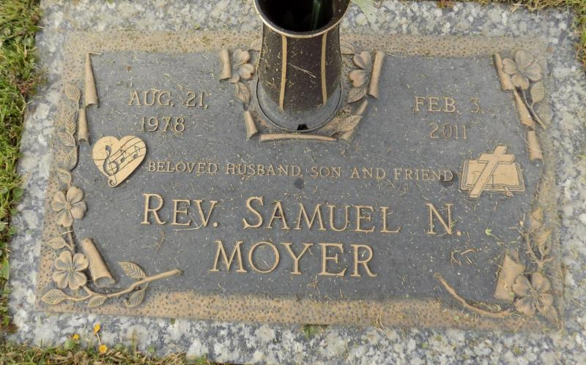

Samuel Nelson Moyer was born August 21, 1978 in Arlington, Washington, went home to sing in Heaven's Choir on Thursday, February 3, 2011, at the age of 32 years. He was known for his singing, preaching and loving. He graduated from Marysville High School in 1997 and from Southwestern Assemblies of God University in 2002. He was a resident of Gramercy, LA. He was the Assistance Pastor of First Assembly of God LaPlace, LA for seven years. He was also a licensed minister with the Assemblies of God. He worked tirelessly to let others know god's great love.
He is survived by his loving wife, Roxanne Moyer of nine years; his parents: Edward and Mary Moyer of Maryville, Washington; his sister, Sarah (Jason) Caldwell; and his brother, Eric Moyer; also his in-laws: Wayne and Dorothy Guidry of LaPlace, LA; brother-in-law, Chad (Tonya) Guidry; sisters-in-law, Candice (Dennis) Clancy and Theresa (Casey) Madere; his nieces and nephews: Iris and Esther Caldwell, Dylan Johnson, Donald (DJ) McLean, Cheyenne, Connor and Rita Guidry, Harvey and Michael Madere. Preceded in death by his grandparents. Sam will be missed by his fellow workers, friends and family. You may visit his website at www.crucifiedinchrist.com to listen to his music and preaching.
A Memorial Service will be held Saturday, February 5, 2011 at 2:00 p.m. at First Assembly of God, 3001 Hwy. 51, LaPlace, LA. Pastor Curtis Porche, officiating. There will be a Gravesite Service on Monday, February 7, 2011 at 1:00 p.m. at St. John Memorial Garden of LaPlace, LA. Bardell's Mortuary of Mt. Airy, LA in charge. Information: (985) 535-6837.
Times-Picayune, The (New Orleans, LA)
Saturday, February 5, 2011

