Gerald A. Muller
October 26, 1942 – April 8, 2003
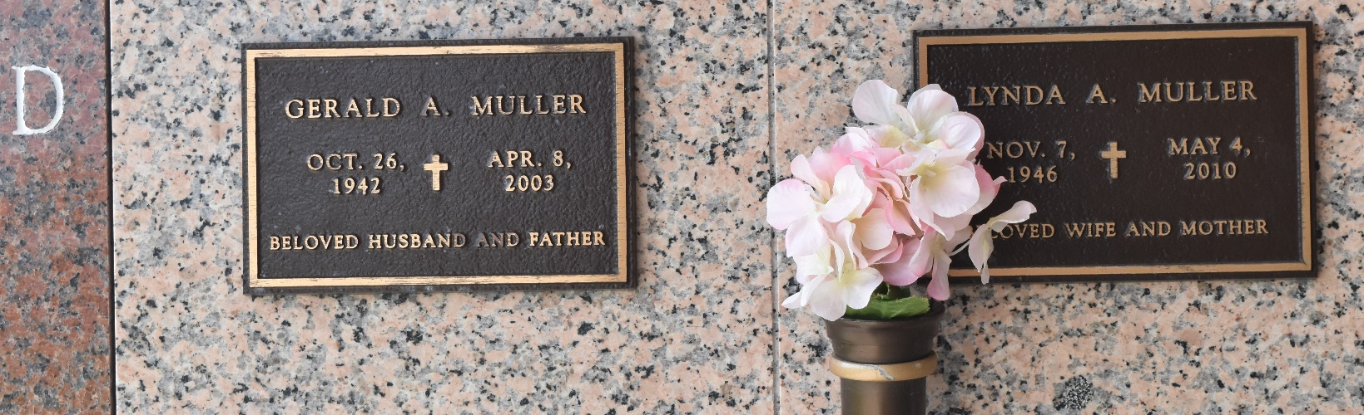

Gerald A. Muller at Grand Cayman Brittish West Indies on Tuesday, April 8, 2003. Beloved husband of Linda Arceneaux Muller. Father of Richard, Eric, Keith, Scott and Neil Muller and Denise M. Satterlee. Stepfather of Wayne and Troy Grassel, Shannon Haygood. Brother of Donald A. Muller and Kathleen Muller Orta. Also survived by twelve (12) grandchildren.
Relatives and friends of the family, also members of Jefferson Parish Dart Association and Patrons of Muller Hardware are invited to attend the Funeral Mass from The Jefferson Chapel of Tharp-Sontheimer-Tharp Funeral Home, 1600 N. Causeway Blvd. at 43rd Street, Metairie, LA on Monday, April 14, 2003 at 11:00 o'clock A.M. Interment will be PRIVATE. Visitation on Sunday, April 13, 2003 from 5 to 9 o'clock P.M. and on Monday from 10:00 o'clock AM until 11:00 o'clock AM. For information call: 835-2341.
The Times-Picayune, New Orleans, Louisiana
January 17, 2003

