Martin D. Muller
April 22, 1932 – October 27, 2020
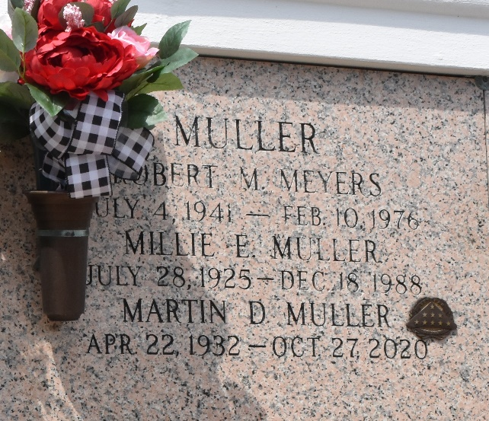

On Tuesday, October 27, 2020, Martin Muller, 88, passed away peacefully at his granddaughter's home in New Orleans, LA. He was surrounded by his family. Martin was born on April 22, 1932, in New Orleans, LA to Joseph and Irene (Vinzant) Muller. Raised in New Orleans, LA, he made LaPlace, LA home for 52 years, where he served as little league coach and athletic director of Riverlands Civic Association. He served in the Army in Germany for 2 years and was a successful business owner for 29 years.
He was preceded in death by his parents, his wife Millie Muller, his siblings, Joseph Muller, Wilbert Muller, Jesse Muller, Elizabeth Orbeck, James Muller, Thomas Muller, and his companion of eighteen years, Iris Waguespack.
He is survived by two children, Toni Hernandez and Martin Muller, Jr (Branesha). He was a beloved PawPaw to Jennifer Webre, Carolyn Sutton (Matthew), Alyssa Hernandez, Javier Hernandez, Jonathan Muller, Devin Muller, Anthony Muller, Brandon Muller, and Xade Muller; he is also survived by three great-granddaughters.
He was known for his quick wit, infectious smile, and compassionate heart. He spent his free time working in his beautiful yard, spending time with his family, and frequenting the casino. He will be dearly missed by all who loved him.
Relatives and friends are invited to attend the Visitation and Funeral Service at Millet-Guidry Funeral Home, 2806 W. Airline Hwy, LaPlace on Saturday, October 31, 2020. Visitation will be held from 9:00 a.m. to 11:00 a.m. with the service to immediately follow at 11:00 a.m. Interment in St. John Memorial Gardens Cemetery.
Millet-Guidry Funeral Home, LaPlace, Louisiana
October 29, 2020

