Pierce Alexander Muller
May 16, 2007 – September 1, 2009

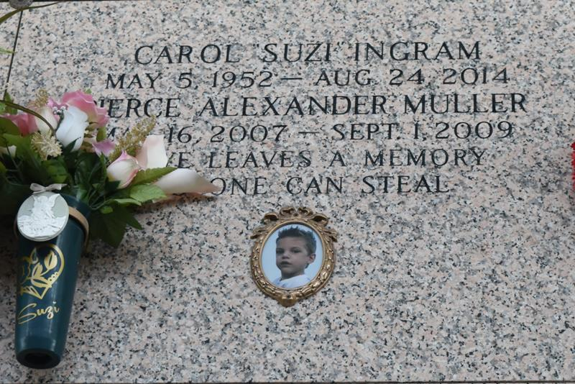

Pierce Alexander Muller, 2 years old, of Ponchatoula died Tuesday, Sept. 1, 2009, in North Oaks Medical Center. He was born on Wednesday, May 16, 2007, in Hammond, La.
Surviving are his mother, Carissa Muller; grandparents, Suzi and Paul Ourso; grandfather, Walter Muller; three aunts, Rachel Michel and her husband Buster, Samantha Kugler and her husband Andy and Christina Ourso; two uncles, Derrin Barras and his wife Melissa and Adam Ourso and his wife Carly; and seven cousins.
He is preceded in death by great-grandparents, Don and Doris Ingram and Joseph and Rosemary Muller.
Visitation will be Saturday, Sept. 5, 2009, from 8 a.m. until 10 a.m. at the Harry McKneely & Son Funeral Home in Ponchatoula. Services will be held in the funeral home chapel on Saturday, Sept. 5, 2009, at 10 a.m., with Rev. Josh Day officiating.
Interment will follow in the St. John Memorial Gardens, LaPlace.
An online guest book is available at www.harrymckneely.com.

L'Observateur, LaPlace, Louisiana
Friday, September 4, 2009

