William Charles Murphy
September 10, 1927 – September 20, 2002

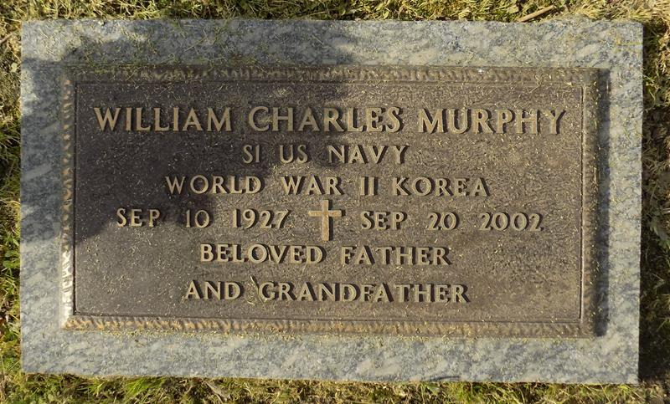

William C. "Bill" Murphy, a retired owner of a custom store-fixture fabrication shop, died Sept. 20 of complications from strokes and sepsis in Erlanger, Ky. He was 75. Mr. Murphy was born in Youngstown, Ohio, and lived most of his life in the New Orleans area and in Erlanger for three years. He was a Navy veteran of World War II and the Korean War. In 1946-47 he was part of "Operation Hijump," the organization of the Navy Antarctic Developments Project.
Survivors include two daughters, Wendy Murphy and Karen Murphy Parenteau; three sons, William "Bill" Murphy Jr. and Thomas and Keith Murphy; five stepdaughters, Alice Babin, Kathy Poche Scanlan, Terry Schellhaas, Wendy Schoen and Penny Johnson; five brothers, Richard, Jack, Harry, James and Larry Murphy; five sisters, Mary M. Cyr, Margaret M. Nardi, Patricia Corbin, Kay Marsh and Ruth Hoppe; four grandchildren; six stepgrandchildren; and six great-grandchildren.
A graveside service will be held Saturday at 1 p.m. at St. John Memorial Gardens Cemetery in LaPlace.
Times-Picayune, The (New Orleans, LA)
Thursday, November 14, 2002

