Gene Paul Naquin
August 11, 1941 – July 1, 2007
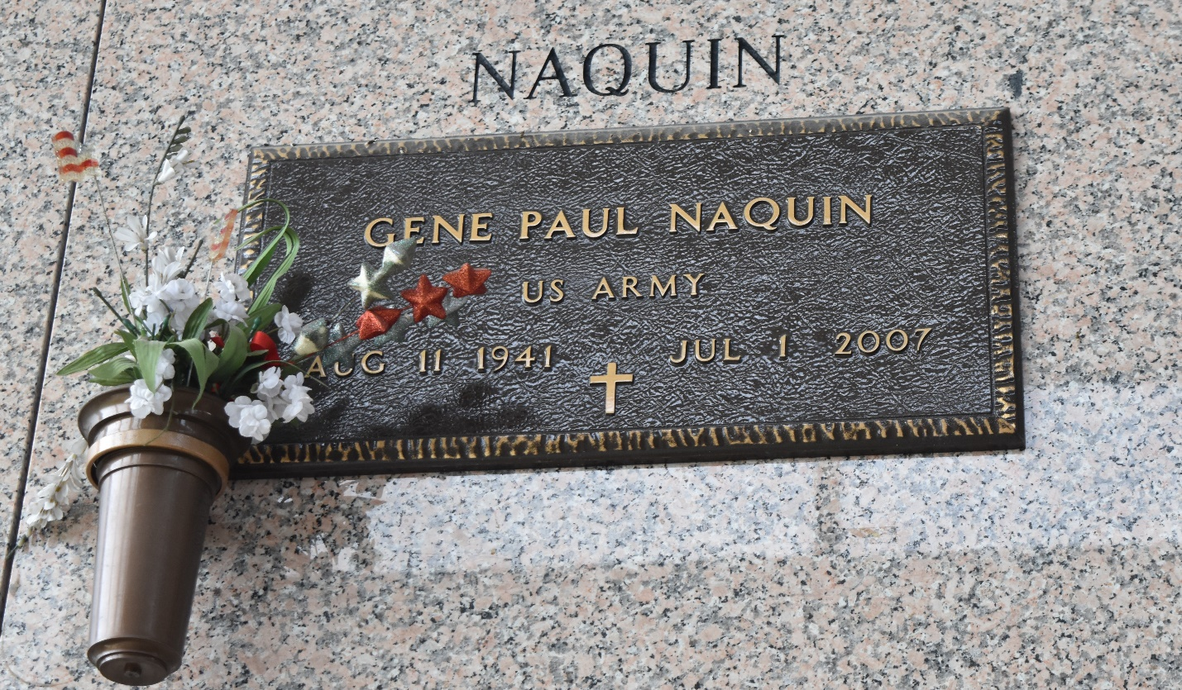
Gene P. Naquin, on Sunday, July 1, 2007 at 1:30 a.m.
Beloved husband of Sue Naquin. Father of Aaron Shaffer and G. Paul Naquin, Jr. Grandfather of Parker John Shaffer and Tatum Shaffer. Son of the late Wilmer and Velma Naquin. Brother of Bonnie Dicharry and Connie Magendie. Age 65. A native of New Orleans and a resident of Laplace for the past 35 years.
Relatives and friends and employees of Winn Dixie Laplace, are invited to attend services. Visitation at Millet-Guidry Funeral Home, 2806 W. Airline Hwy, Laplace on Tuesday, July 3, 2007 from 11 am to 2 pm. Followed by religious services at the funeral home chapel at 2 pm. Burial in St. John Memorial Gardens Cemetery, Laplace.
The Times-Picayune, New Orleans, Louisiana
Jul. 3, 2007

