Houston Narcisse
Abt 1947 – March 16, 2024
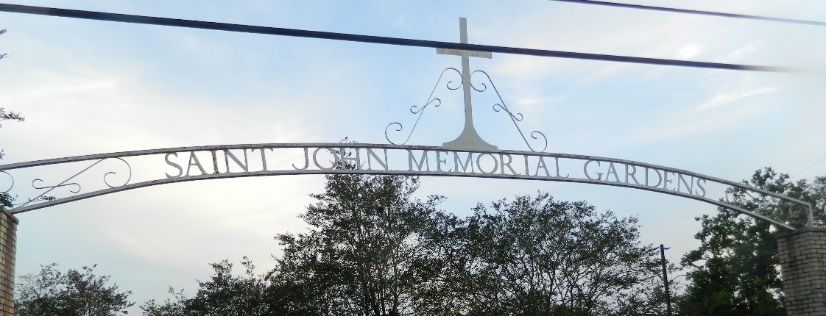

Houston Narcisse died on Saturday, March 16, 2024 at Ochsner Medical Center, Kenner, LA. Son of the late Viola Steib and Wilbert Narcisse, Sr. Brother of Clifton, Geraldine, Elaine, Martin, Wilbert, Jr. (Marva) and the late Joan Narcisse. Also survived by a host of cousins, other relatives and friends. Age 77 years. A native of Vacherie, LA and resident of LaPlace, LA.
Relatives and friends of the family are invited to attend the funeral service at Robottom Mortuary, 850 Hwy. 44 (River Road), Reserve, LA on Saturday, March 23, 2024 at 10:00 a.m. Rev. Herman Clayton, Jr. of St. Matthew Baptist Church, Paulina, LA. Interment St. John Memorial Garden Cemetery, LaPlace, LA. Visitation at the above-named funeral home from 8:00 a.m. until service time. Serviced by Robottom.
The Times-Picayune, New Orleans, Louisiana
Mar. 22 to Mar. 23, 2024

