Huey Narcisse Jr.
July 30, 1979 – February 23, 2005
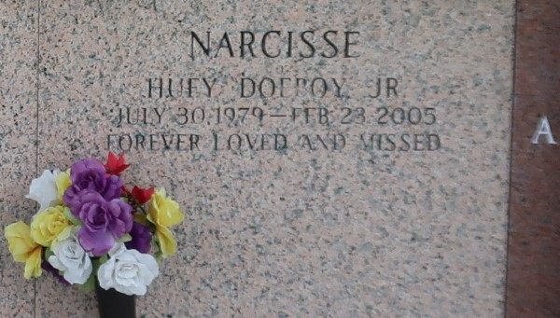

Huey 'Doe Boy' Narcisse Departed This Earthly Life And Entered Into Eternal Rest On February 23, 2005 At River Parish Medical Center Of Laplace, LA.
Beloved Son Of Emma And Huey Narcisse, Sr. Of Laplace, LA. Fiance' Of Ashley Smith Of Laplace, LA. Loving Brother Of Charleetha Narcisse Of Laplace, LA. Grandson Of Florence Brown Of Jackson, MS. Also Survived By Aunts, Uncles, Cousins, Other Relatives And Friends.
Relatives And Friends Of The Family, Also Pastors, Officers And Members Of The Beechgrove Baptist Church Of Reserve, LA, The Word Of Life Christian Center Of Gonzales, LA And All Neighboring Churches Are Invited To Attend The Funeral Services On Saturday, March 5, 2005 At 12:00 Noon At Beechgrove Baptist Church, 117 Beechgrove Dr., Reserve, La. Rev. Wesley Anderson Sr. Officiating. Interment In St. John Memorial Garden, Laplace, LA. Visitation Will Be At The Church From 9:00 A.M. Until Service Time.
Times Picayune, New Orleans, Louisiana
March 4, 2005

