Travalen LaDarious Narcisse
November 5, 1990 – January 26, 2013
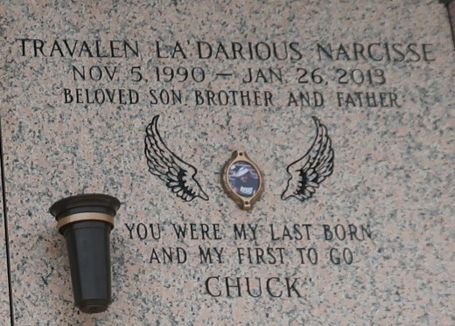

Travalen "Chuck" La'Darious Narcisse departed this life on Saturday January 26, 2013, in Laplace, La., Age 22, Son of Yolanda Narcisse and Donald London, Brother of Olonzo Narcisse, Grandson of Barbara Narcisse, Great Grandson of Mildred Narcisse, also survived by step mother Rainere B. London, aunts, uncles and a host of other relatives and friends.
Service will be held on Saturday February 2, 2013 at 11: 00 am at Providence B.C., 132 Union Lane Montz, La., Bishop Ronald Frank Officiating and Rev. Donald Brown Sr., host pastor Visitation at 10: 00a.m. at the Church, Burial in St. John Memorial Gardens, Laplace, La. Professional Services Entrusted to Hobson Brown Funeral Home 134 Daisy St. Garyville, La 985-535-2516.

The Times-Picayune (New Orleans, LA)
Jan. 31 to Feb. 1, 2013

