Steve M. Navarre
January 5, 1952 – June 12, 2005
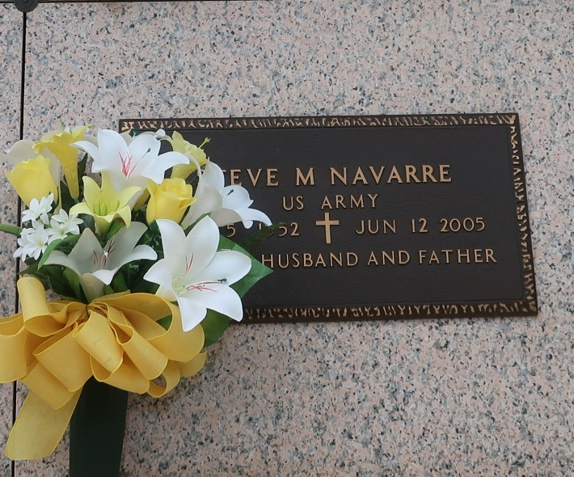

Steve M. Navarre, on Sunday, June 12, 2005 at 10:55 A.M. Beloved husband of Debra Bautsch Navarre. Father of Rachel, Rebecca and Renee Navarre. Son of Mary Ann Naquin and the late Frank J. Navarre, Sr. Brother of Karen N. Pope, Dennis and Frank Navarre, Jr. and the late Lynn and Larry Navarre. Age 53 years. A native of Independence, LA and a resident of LaPlace, LA for the past 23 years.
Relatives and friends of the family are invited to attend services. Visitation at Ascension of Our Lord Catholic Church, Laplace, LA on Wednesday, June 15, 2005 from 5:00 P.M. until 9:00 P.M. and on Thursday, from 9:00 A.M. to 10:00 A.M. Followed by a Mass of Christian Burial at 10:00 A.M. Burial in St. John Memorial Gardens, Laplace, LA. MILLET-GUIDRY FUNERAL HOME, LaPlace, LA in charge of arrangements.

The Times-Picayune (New Orleans, LA)
Jun. 14, 2005

