Alonzo Berry Nellums
November 11, 1943 – November 10, 2018
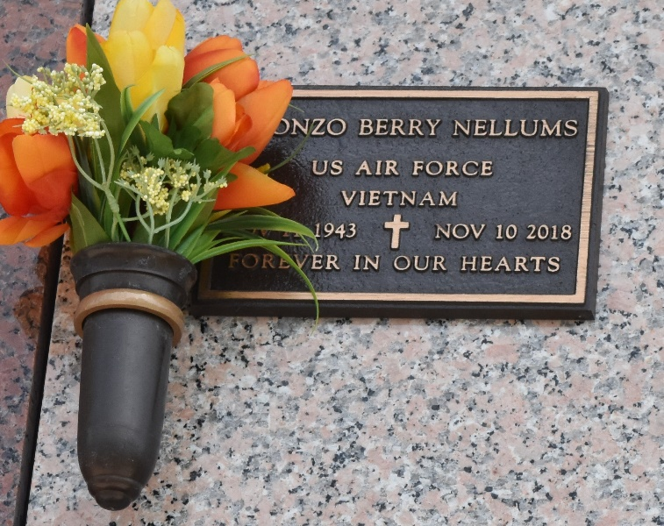

Alonzo Berry Nellums, born November 11, 1943, in Picayune, Mississippi, passed away peacefully, surrounded by his family, at his home in La Place on Saturday, November 10, 2018. He was 74 years old.
He is survived by his beloved wife, Marcie Borden Nellums; and his five children-Felicia Nellums Janak (James), Berry Nellums (Marlene), Les Nellums, Victoria Nellums Jones (Christopher), Gwen Nellums Erwin (Brad) and his four stepchildren Deborah Ralser Varnam (Robert Jr), Ronald Ralser Jr, Richard Ralser (Kim), Michael Ralser (Terri); his siblings, Gwendolyn Nellums Dufrene (Milton), Janna Faye Nellums Ballard, Fannie Nellums Salter and Michael Nellums.
He is preceded in death by his parents; William Thomas Nellums and Nola Quevas Nellums, and his sister, Tommie Dee Nellums Fornea. He also leaves 15 grandchildren, and 1 great grandchild.
Relatives and friends are invited to attend a funeral service at Ascension of Our Lord Church 1900 Greenwood Drive, La Place, Louisiana on Saturday, December 1, 2018 at 11:00 a.m. followed by the interment at St. John Memorial Gardens Cemetery 2205 West Airline Highway in La Place. Visitation will begin at 10:00 a.m. In lieu of flowers, mass and prayer requests would be greatly appreciated.

The Times-Picayune (New Orleans, LA)
Nov. 24 to Nov. 28, 2018

