Kim (Palmisano) Nicolosi

January 24, 1960 – August 14, 2010

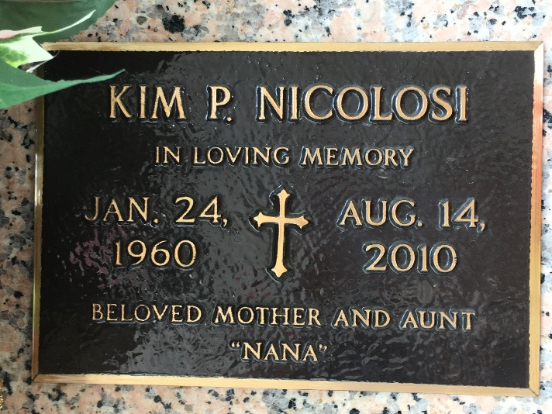

Photo by Team T Lo

Kim Palmisano Nicolosi passed away on Saturday, August 14, 2010. She was 50, a native of New Orleans and a resident of Metairie for the past 23 years.  
 Wife of Gerald Nicolosi. Mother of Brandon, Jeremy (fiancee, Jessica) and Stephany Nicolosi. Daughter of Yvonne 'Snow' Fischer Palmisano and the late Melvin Palmisano. Sister of Karen Palmisano Quillen (husband, Timothy) and the late Debra Palmisano Chaput. Sister-in-law of Juanita Mineo (husband, John). Also survived by many nieces and nephews.  
 Relatives and friends are invited to attend the Memorial Service at the Kenner Funeral Home of L. A. Muhleisen and Son, 2607 Williams Blvd., on Friday, August 20, 2010 at 11:00 a.m. Friends may visit after 9:00 a.m. In lieu of flowers, donations to assist with funeral expenses, c/o Karen Quillen, 240 Janet Dr., St. Rose, LA 70087, preferred.

The Times-Picayune (New Orleans, LA)

August 19, 2010