Pythian Noah
May 11, 1939 – January 14, 2022
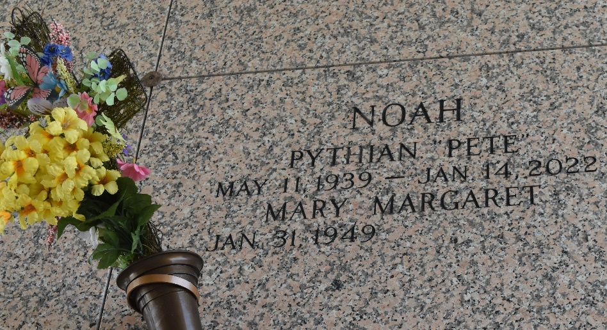

Pythian Noah, Jr., affectionately known as “Pete” entered into eternal rest on Friday, January 14, 2022. Pete was the son of the late Reverend Pythian Noah Sr. and the late Anna Phillips Noah. Beloved husband of Mary Margaret Noah. Father of Pythian Noah III (Veronica), Michael Noah (Muriel), Kim Marshall (Rodney), Darnell Hunter, Marvin Davis, Peter Davis, Pamela Noah, Venus Simms (Gerard), Louis Noah, and Adrienne Cadres. He was the brother of Anna Pierre (Roosevelt), Raymond Noah (Tuesday), Clara Taylor, Alvin Noah (Jennifer) and the late Victoria Sanders, Orelia Lyons (Usia), James Noah (Alice), Ray Melvin Noah, Daniel Noah, and Nathaniel Noah. He is also survived by 22 grandchildren, 15 great-grandchildren, 2 great-great-grandchildren, and host of nieces, nephews, cousins and other relatives and friends.
Relatives and friends of the family, also Pastors, Members of Celebration Church, and employees of St. John the Baptist Parish School System, are invited to attend the funeral service on Thursday, January 20, 2022 at 11:00 a.m. at First Assembly of God Church 3001 US-51 La Place, LA 70068. In accordance with the CDC guidelines for COVID-19 all in attendance must wear a mask and practice social distancing. Visitation at the above-named church at 10:00 a.m. until time of service. Interment at St. John Memorial Gardens, LaPlace, LA immediately after the service.

The Patrick H. Sanders Funeral Home, LaPlace, Louisiana

