Verda Faye (Jones) Noto
February 18, 1932 – February 6, 2009
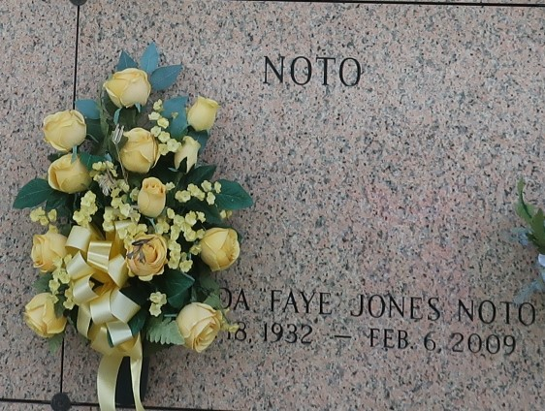

Verda "Faye" Jones Noto on Friday, February 6, 2009. Beloved wife of Nicholas S. Noto. Mother of Rose Lodrigues and husband Bobby, Elizabeth Hubbard and Nicholas S. Noto, Jr. Grandmother of Christopher Martin and wife Jennifer, Garrad Lodrigues and Tracy Murray. Great-grandmother of baby Madelyn Martin. Sister of Guy R. Jones. She will be missed greatly by family, nieces, nephews and friends. Age 76 years. A native of Oklahoma and a resident of LaPlace, La. for the past 28 years.
Relatives and friends are invited to attend services. Visitation at St. Joan of Arc Catholic Church, 529 West 5th Street, LaPlace, La on Monday, February 9, 2009 from 11:00am to 2:00pm. Followed by Religious Services at the church at 2:00pm. Burial in St. John Memorial Gardens Cemetery, LaPlace, La. Arrangements by Millet-Guidry Funeral Home, LaPlace, La.

The Times-Picayune, New Orleans, Louisiana
Feb. 8, 2009

