Jonathan Brennan Oney
May 10, 1985 – November 16, 2019
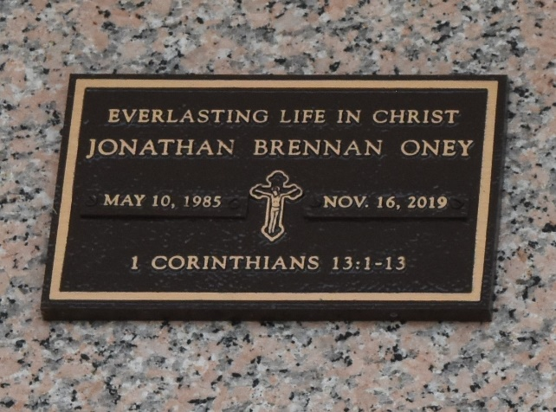

Jonathan Oney, age 34, passed away in a motorcycle accident in Clark County, Nevada (where he had been living the past year) on November 16, 2019.
Relatives and friends of the family are invited to attend a memorial Mass in honor of Jonathan on Saturday, November 23, 2019 at St. Joan of Arc Catholic Church in LaPlace, LA. This will be a memorial mass service only. Visitation with the family and a musical prelude will begin at 9:30 am at the church and will be immediately followed by the memorial Mass, which will be presided by Very Reverend Simon Peter Engurait, Vicar General, Diocese of Houma-Thibodaux.
Jonathan is survived by his 8-year-old daughter, Alaysia and her mother, Alyse Mills; his mother, Leslie DeJean, his father, Deacon Larry Oney, his stepmother, Andi Oney; and his brothers and sisters, Christopher, Michael Jude, Adrienne, and Alex David Oney. Jonathan was preceded in death by his grandparents, Beatrice Allen, Clifton Oney, and George and Doris DeJean. Jonathan was a free-spirited person and everyone he met instantly liked him. He was non-judgmental and full of life and adventure.

L'Oservateur, LaPlace, Louisiana
Tuesday, November 19, 2019

