Elizabeth Irene Orbeck
May 8, 1929 – September 15, 2008
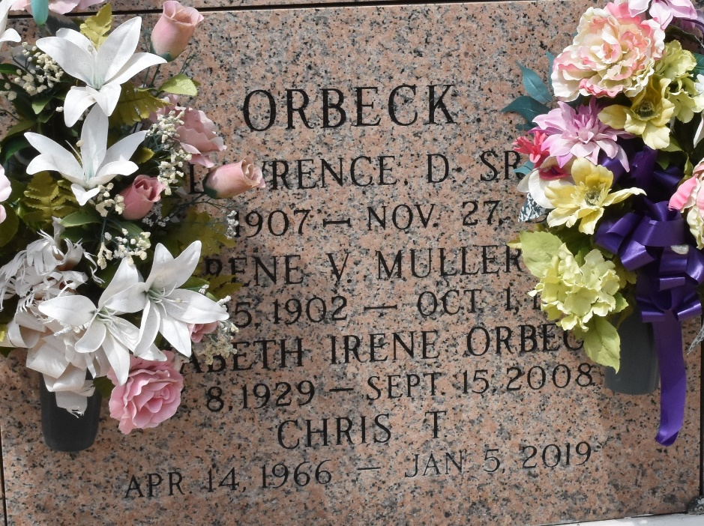

Elizabeth Irene Orbeck on Monday, September 15, 2008 at 10:20AM. Beloved wife of the late Lawrence D. Orbeck, Sr. Mother of Lawrence, Jr., and wife Thea, and Chris T. Orbeck. Grandmother of Lawrence III, Jarret, Felicia and Candace. Age 79 years, a native of New Orleans and a resident of LaPlace.
Visitation at Millet-Guidry Funeral Home, 2806 W. Airline Hwy., LaPlace, La., on Wednesday, September 17, 2008 from 5PM to 9PM and on Thursday from 8AM to 10AM. Followed by Religious Services at the Funeral Home Chapel at 10AM. Burial in St. John Memorial Gardens Cemetery, LaPlace, LA.
The Times-Picayune, New Orleans, Louisiana
Sep. 17 to Sep. 18, 2008

