Iris (Naquin) Oubre
September 8, 1944 – October 10, 2010
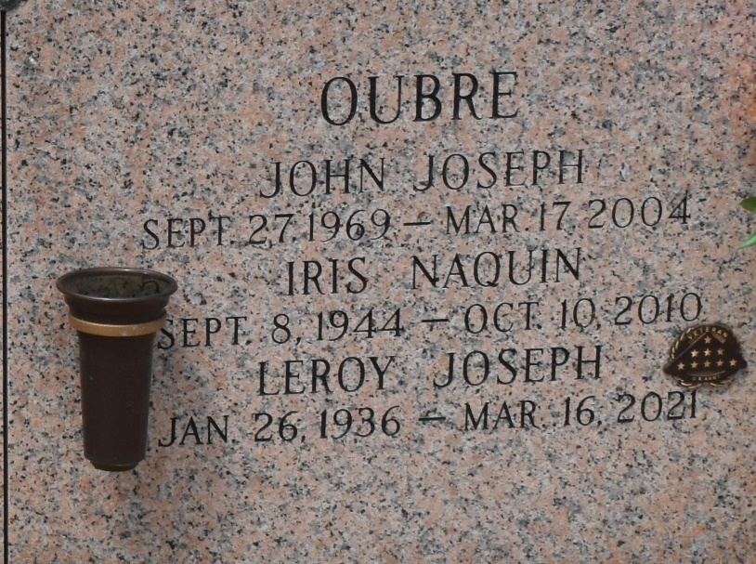

Iris Naquin Oubre went into the arms of our heavenly Father on Sunday, Oct. 10, 2010. She was the beloved wife of Leroy Oubre, mother of Eric Oubre, Ann Comardelle and husband Ernie, Adrian Oubre and the late John Oubre, grandmother of Trevor and Tori Comardelle, daughter of the late Edward and Jeanne Gaudet Naquin, and sister of Raymond, Allen, Martin and James Naquin, Marjorie Andras, Brenda Arceneaux and the late Catherine Picou and Gerald Naquin. She was 66, a native of Thibodaux and a resident of LaPlace and Paulina.
Relatives and friends, also Riverlands Community Care Nursing Home, are invited to attend services. Visitation at Millet-Guidry Funeral Home, 2806 W. Airline Highway, LaPlace, Friday, Oct. 15, from 9 a.m. until Mass in the chapel at 11 a.m. Burial in St. John Memorial Gardens Cemetery, LaPlace.
The Advocate, Baton Rouge, Louisiana
Oct. 14, 2010

