John Joseph Oubre
September 27, 1969 – March 17, 2004
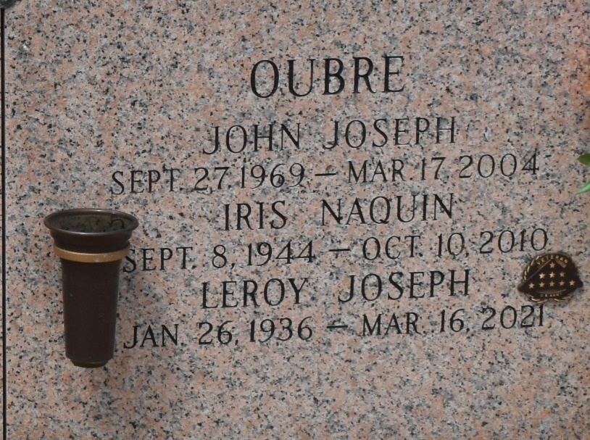

OUBRE, JOHN J. A resident of Baton Rouge, he died Wednesday, March 17, 2004, at 8:23 a.m. He was 34 and a native of LaPlace.

He was the beloved son of Leroy and Iris Naquin Oubre of Paulina; brother of Ann Comardelle and Eric and Adrian Oubre; and fiancé of Morna Alexander.

Relatives and friends of the family are invited to the service. Visitation at Millet-Guidry Funeral Home chapel, 2806 Airline Highway, LaPlace, from 9 a.m. Saturday, March 20, 2004, until service at 11 a.m. Interment in St. John Memorial Gardens.

The Advocate, Baton Rouge, Louisiana
March 19, 2004

