Leroy Joseph Oubre
January 26, 1936 – March 16, 2021
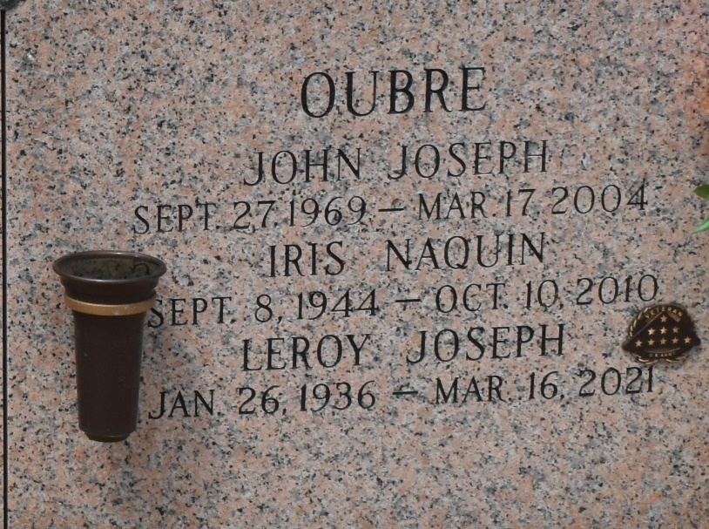

Leroy Joseph Oubre passed away peacefully on Tuesday, March 16, 2021 at the age of 85. He was born in LaPlace, LA and was a resident of Paulina, LA.
Beloved husband of the late Iris Naquin Oubre. Loving father of Eric M. Oubre, Adrian P. Oubre, Ann M. Comardelle (Ernie) and the late John J. Oubre. Grandfather of Trevor, Tori and Novajane Comardelle. Great grandfather of Eden and Kylen. Son of the late Lillian Chenier Oubre and Frank Remy "Regis" Oubre. Brother of Dorothy "Dot" Massi, and the late Ned J. Oubre, Harry "Whitey" Oubre, Lorraine Oubre, Theresa Gautreau and Roline Larousse. Also survived by many nieces and nephews.
Relatives and friends are invited to attend the Visitation and Funeral Mass at Millet-Guidry Funeral Home, 2806 W. Airline Hwy., LaPlace, LA on Thursday, March 18, 2021. Visitation from 9:00 a.m. to 11:00 a.m. followed by a Funeral Mass at 11:00 a.m. Interment in St. John Memorial Gardens Cemetery, LaPlace.
Millet-Guidry Funeral Home, LaPlace, LA
March 17, 2021

