Sheila M. Oubre

October 30, 1957 – December 25, 2021
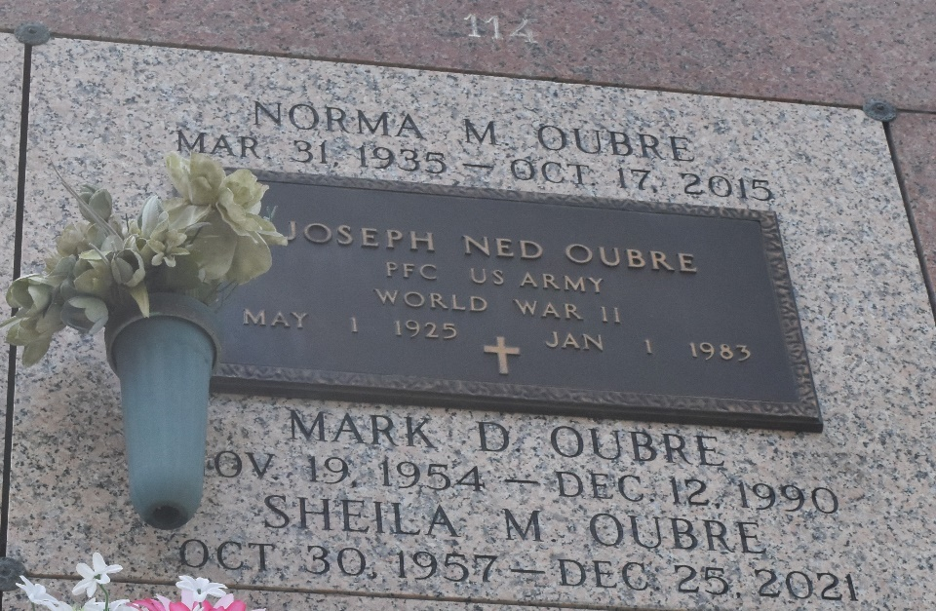

Sheila Marie Oubre’s passing at the age of 64 has been publicly announced by Kiehn-Varner Funeral Home and Cremation Service in Cordell, OK.
The most recent obituary and service information is available at the Kiehn-Varner Funeral Home and Cremation Service website.
Legacy.com

