Alix (Vallecillo) Pagoaga
June 3, 1936 – March 15, 2015
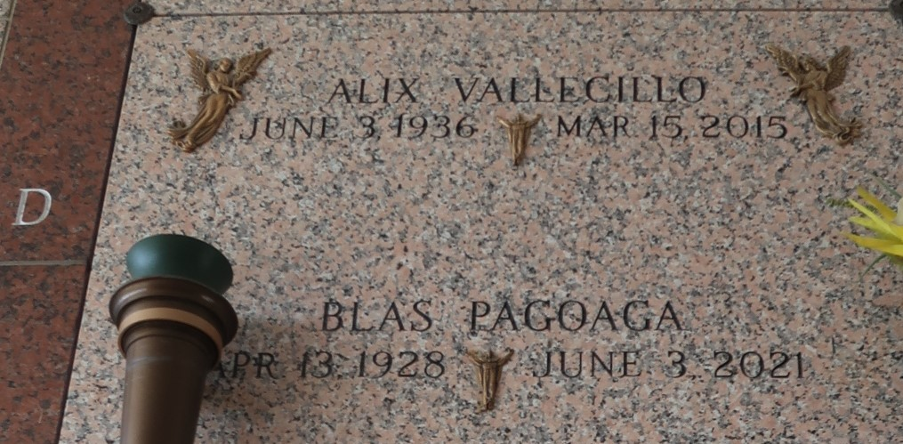

Alix Vallecillo Diaz passed away on Sunday, March 15, 2015. She was 78, a native of Honduras and a resident of LaPlace. Beloved wife of Blas Pagoaga. Mother of Aldo Armando Pagoaga, Elvin Antonio Pagoaga, Nelly Dilcia Pagoaga, Soneyda Xiomara Hart, Iliana Duggan, Lesly Phillips, Juan Carlos Pagoaga, Cesar Augusto Pagoaga and the late Blas Edgardo Pagoaga. Daughter of the late Martina Diaz and Florencio Vallecillo. Also survived by many grandchildren, great-grandchildren, nieces and nephews. She was preceded in death by 17 siblings. Relatives and friends are invited to attend the Funeral Mass at St. Joan of Arc Catholic Church, 529 W. 5th St., LaPlace on Thursday, March 19, 2015, at 12:00 p.m. Visitation will begin in church at 10:30 a.m. Interment in St. John Memorial Gardens Cemetery.
Unknown source
**
Alix Vallecillo Diaz, 78, passed away on Sunday, March 15, 2015. She was 78, a native of Honduras and a resident of LaPlace. Diaz was the beloved wife of Blas Pagoaga; mother of Aldo Armando Pagoaga, Elvin Antonio Pagoaga, Nelly Dilcia Pagoaga, Soneyda Xiomara Hart, Iliana Duggan, Lesly Phillips, Juan Carlos Pagoaga, Cesar Augusto Pagoaga and the late Blas Edgardo Pagoaga; and daughter of the late Martina Diaz and Florencio Vallecillo.
She is also survived by many grandchildren, great-grandchildren, nieces and nephews. She was preceded in death by 17 siblings. Relatives and friends are invited to attend the Funeral Mass at St. Joan of Arc Catholic Church, 529 W. 5th St., LaPlace on Thursday, March 19 at noon. Visitation will begin in church at 10:30 a.m. Interment is in St. John Memorial Gardens Cemetery. To view or sign the online guest book, please visit milletguidry.com.
L'Observateur, LaPlace, Louisiana
Wednesday, March 18, 2015

