Roy L. Paine

July 22, 1927 – May 8, 2001

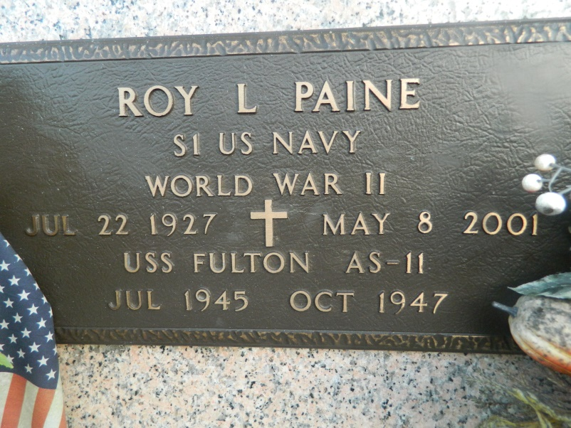

Roy L. Paine on Tuesday, May 18, 2001 at 7:26 PM. Beloved husband of Josephine P. Dufresne Paine. Father of Deborah Nehls of Denver, IA, Cynthia Rasmus of Destrehan, LA. Barbara Mahne Smith of Nora Springs, IA, Julie Underriner of St. Ansgar, IA, and Susan Wilde of Grafton, IA. Stepfather and stepfather-in-law of Patricia Dufresne, Sheryl D. and Wade Gauthreaux, Emily D. and Robert Voros, Jr. of Laplace, LA, Keith Dufresne of Loranger, LA. Also survived by 13 grandchildren, 10 great-grandchildren and 11 step grandchildren. Predeceased by parents; William Paine, Sr. and Alma Clough Paine and 4 brothers and 4 sisters. Aged 73 years, a native of Nora Springs, Iowa and a resident of Norco, LA for the past 6 years. He achieved the rank of Seaman 1st Class serving on the U.S.S. Fulton (AS-11) July 1945 - October 1947.  
 Relatives and friends of the family are invited to attend the funeral services at Sacred Heart of Jesus Catholic Church, 401 Spruce St., Norco, LA on Friday, May 11, 2001 at 1:30 PM. Burial in St. John Memorial Cemetery - Laplace. Visitation at the church on Friday from 11:30 AM until services. In lieu of flowers Masses preferred of donations to River Parish Hospice, 704 Williams Blvd., Kenner, LA 70062.  
 MILLET GUIDRY FUNERAL HOME

Times-Picayune, The (New Orleans, LA) - Thursday, May 10, 2001

Contributed by Jane Edson