Virginia L. Parkes
November 21, 1910 – December 8, 2002
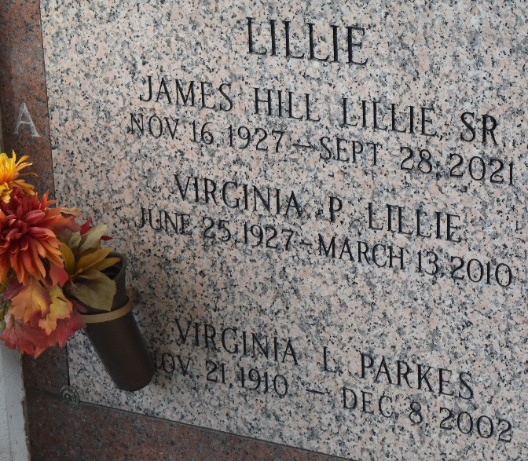

Virginia L. Parkes passed away On Sunday December 8, 2002, At 3:15 P.M.
Beloved Wife Of The Late Harry Parkes. Mother Of Virginia Lillie And The Late Harry Parkes. Also Survived By 7 Grandchildren, 12 Great Grandchildren And 2 Great Great Grandchildren. Age 92 Years. A Native Of Tennessee And A Resident Of Laplace, LA For The Past 34 Years.
Relatives And Friends Of The Family Are Invited To Attend Services. Visitation At Millet-Guidry Funeral Home, 2806 West Airline Highway, Laplace, La. On Tuesday, December 10, 2002 From 1 P.M. Until 2 P.M. Followed By Religious Services In The Funeral Home Chapel At 2 P.M. Burial In St. John Memorial Gardens, Laplace.
Times Picayune, New Orleans, Louisiana
December 10, 2002

